

OLFACTORY PERCEPTION MINING: MULTI-LABEL EMOTION ANALYSIS OF YOUTUBE PERFUME REVIEWS USING MACHINE LEARNING AND DEEP LEARNING

ECE ÇANGA

SEPTEMBER 2026

ÇANKAYA UNIVERSITY

GRADUATE SCHOOL

COMPUTER ENGINEERING DEPARTMENT
COMPUTER ENGINEERING MASTER'S THESIS

OLFACTORY PERCEPTION MINING: MULTI-LABEL EMOTION ANALYSIS OF YOUTUBE PERFUME REVIEWS USING MACHINE LEARNING AND DEEP LEARNING

ECE ÇANGA

SEPTEMBER 2026

Title of Thesis: Olfactory Perception Mining: Multi-Label Emotion Analysis of YouTube Perfume Reviews Using Machine Learning and Deep Learning
Submitted by: Ece ÇANGA

Approval by the Graduate School of Çankaya University
_____________________
Prof. Dr. Mehmet YAZICI
Director

I certify that this thesis satisfies all the requirements as thesis for the Master's degree in Computer Engineering
_____________________
Prof. Dr. Murat KOYUNCU
Head of Department

This is to certify that I have read this thesis and that in my opinion it is fully adequate in scope and quality, as thesis for the Master's degree in Computer Engineering

_____________________
Assoc. Prof. Dr. Serdar ARSLAN
Supervisor

Thesis Defense Date: 24.09.2026
Thesis Jury Members:
Assoc. Prof. Dr. Serdar ARSLAN | Çankaya University |  | ______________
Assoc. Prof. Dr. AYDIN KAYA |  | Hacettepe University | ______________
Assist. Prof. Dr. Abdül Kadir GÖRÜR |  | Çankaya University | ______________

STATEMENT OF NONPLAGIARISM

I hereby declare that all statements in this statement has been obtained and presented in accordance with academic rules and ethical conduct. I also declare that, as required by these rules and conduct, I have fully cited and referenced all material and results that are not original to this work.

Name Last Name: | Ece ÇANGA
Signature:
Date:

ABSTRACT

Olfactory Perception Mining: Multi-Label Emotion Analysis of YouTube Perfume Reviews Using Machine Learning and Deep Learning

ÇANGA, Ece
COMPUTER ENGINEERING MASTER'S THESIS

Supervisor: Assoc. Prof. Dr. Serdar ARSLAN

September 2026, 107 pages

This thesis develops and evaluates a reproducible natural language processing pipeline for multi-label emotion analysis of YouTube perfume-review transcripts. The dataset contains 4,881 transcript rows aggregated into 784 perfume-level observations. Gemini 3.1 Pro supplied reference labels for seven emotions. The benchmark measures agreement with these model-based labels, which have not been verified by human annotators. Logistic Regression, XGBoost, and Random Forest use 58 features derived from NRC, VAD, and four transformer models. BERT and BiLSTM with Attention use transcript text. Each main experiment and structured-feature ablation uses five training seeds. The source-grouped five-fold splits remain fixed, with a decision threshold of 0.3. Results are reported as mean ± standard deviation across seeds. Macro AP is the primary ranking metric. Under YouTube-only training, Logistic Regression has the highest mean Macro-F1 (0.3592 ± 0.0000). Random Forest has the highest mean Macro AP (0.3325 ± 0.0034), and XGBoost has the highest mean Macro ROC-AUC (0.5639 ± 0.0043). BERT shows greater Macro-F1 variation across seeds (0.3502 ± 0.0303). Weighted synthetic augmentation improves some scores and reduces others. Feature-group ablations also show that the best representation depends on the model and metric. The study supports a reproducible comparison of model-based emotion labels. It does not establish one best classifier, agreement with human olfactory judgments, or a general benefit from synthetic data.

Keywords: Sentiment Analysis, Multi-label Emotion Classification, YouTube Transcripts, Machine Learning, Deep Learning, Synthetic Data Augmentation

ÖZET

Koku Algısı Madenciliği: Makine Öğrenmesi ve Derin Öğrenme Kullanılarak YouTube Parfüm İncelemelerinin Çok Etiketli Duygu Analizi

ÇANGA, Ece
BİLGİSAYAR MÜHENDİSLİĞİ YÜKSEK LİSANS TEZİ

Danışman: Doç. Dr. Serdar ARSLAN

Eylül 2026, 107 sayfa

Bu tez, YouTube parfüm inceleme transkriptlerinin çok etiketli duygu analizi için yeniden üretilebilir bir doğal dil işleme hattı geliştirmekte ve değerlendirmektedir. Veri kümesi, parfüm düzeyinde 784 gözlemde birleştirilen 4.881 transkript satırından oluşmaktadır. Gemini 3.1 Pro, yedi duygu için referans etiketleri sağlamıştır. Değerlendirme, insan tarafından doğrulanmamış bu model tabanlı etiketlerle uyumu ölçmektedir. Lojistik Regresyon, XGBoost ve Random Forest, NRC, VAD ve dört Transformer modelinden türetilen 58 özelliği kullanmaktadır. BERT ve dikkat mekanizmalı BiLSTM ise transkript metnini kullanmaktadır. Ana deneyler ve yapılandırılmış özellik ablasyonları beş farklı eğitim tohumu ile yürütülmüştür. Kaynak gruplarını koruyan beş katlı veri bölmeleri sabit tutulmuş ve 0,3 karar eşiği kullanılmıştır. Sonuçlar, tohumlar üzerinden ortalama ± standart sapma olarak sunulmuştur. Birincil sıralama ölçütü Makro AP’dir. Yalnızca YouTube verisiyle eğitimde Lojistik Regresyon en yüksek ortalama Makro-F1 değerine ulaşmıştır (0,3592 ± 0,0000). Random Forest en yüksek ortalama Makro AP (0,3325 ± 0,0034), XGBoost ise en yüksek ortalama Makro ROC-AUC değerini elde etmiştir (0,5639 ± 0,0043). BERT’in Makro-F1 sonuçları tohumlar arasında daha fazla değişmiştir (0,3502 ± 0,0303). Ağırlıklı sentetik veri artırımı bazı sonuçları iyileştirirken diğerlerini düşürmüştür. Özellik grubu ablasyonları da en iyi gösterimin model ve ölçüte göre değiştiğini göstermiştir. Çalışma, model tabanlı duygu etiketlerinin yeniden üretilebilir biçimde karşılaştırılmasını sağlamaktadır. Ancak tek bir en iyi sınıflandırıcıyı, insan koku yargılarıyla uyumu veya sentetik verinin genel yararını ortaya koymamaktadır.

Anahtar Kelimeler: Duygu Analizi, Çok Etiketli Duygu Sınıflandırma, YouTube Transkriptleri, Makine Öğrenmesi, Derin Öğrenme, Sentetik Veri Artırımı

ACKNOWLEDGEMENT

I would like to express my sincere gratitude to my supervisor, Assoc. Prof. Dr. Serdar ARSLAN, for his outstanding guidance, constructive feedback, and continued support throughout this thesis. I am deeply grateful to my mother, my lifelong teacher, for sharing my excitement at every step toward earning this M.Sc. degree; to my father, who has always shown me that engineering is an art; and to my sister, who inspired me to choose software engineering as my path and continues to shape the professional I am becoming. I am especially grateful to my significant other, whose encouragement gave me the confidence to begin and who stood by me at every stage leading to this milestone. Finally, Iris Malikhân holds a special place in the origins of this work as one of the fragrances that helped me recognize how perfumes can tell stories and serve as extensions of human emotion, making them worthy subjects of study.

TABLE OF CONTENTS

STATEMENT OF NONPLAGIARISM iii

ABSTRACT iv

ÖZET vi

ACKNOWLEDGEMENT viii

LIST OF TABLES xiii

LIST OF FIGURES xv

LIST OF SYMBOLS AND ABBREVIATIONS xvi

CHAPTER I 1

INTRODUCTION 1

1.1 BACKGROUND AND MOTIVATION 1

1.2 PROBLEM STATEMENT 2

1.3 RESEARCH AIM AND OBJECTIVES 2

1.4 RESEARCH QUESTIONS 3

1.5 CONTRIBUTIONS 3

1.6 THESIS ORGANIZATION 4

CHAPTER II 5

LITERATURE REVIEW 5

2.1 SENTIMENT ANALYSIS AND EMOTION CLASSIFICATION 5

2.2 NRC AND VAD AFFECT FEATURES 5

2.3 TRANSFORMER-BASED EMOTION FEATURES 6

2.4 MACHINE LEARNING AND DEEP LEARNING MODELS 6

2.5 IMBALANCED MULTI-LABEL EVALUATION 6

2.6 LLM-ASSISTED EMOTION ANNOTATION AND OLFACTORY LANGUAGE 7

2.7 TEXT AUGMENTATION AND SYNTHETIC TRAINING DATA 8

CHAPTER III 9

METHODOLOGY 9

3.1 CHAPTER OVERVIEW 9

3.2 DATASET CONSTRUCTION 10

3.2.1 YouTube Transcript Benchmark Dataset 10

3.2.2 Synthetic Dataset Expansion 17

3.3 DATA PREPROCESSING 19

3.4 LLM-ASSISTED EMOTION ANNOTATION AND REFERENCE LABELING 20

3.5 FEATURE EXTRACTION 23

3.5.1 NRC Emotion Features 24

3.5.2 VAD Features 25

3.5.3 Transformer-Derived Emotion Features 26

3.5.4 Perfume-Level Aggregation Rules 27

3.5.5 Unified Feature Matrix 28

3.6 MACHINE LEARNING AND DEEP LEARNING MODELS 31

3.6.1 Logistic Regression 33

3.6.2 XGBoost 34

3.6.3 Random Forest 34

3.6.4 BERT 34

3.6.5 BiLSTM with Attention 35

3.7 DATA SPLITTING AND TRAINING STRATEGY 35

3.7.1 Source-Grouped Splits and Training Seeds 35

3.7.2 Synthetic Data in Model Training 36

3.8 STEP-BY-STEP PIPELINE EXAMPLE 38

3.8.1 Transcript Excerpt and Feature Values 39

3.8.2 Prediction Results for the Example Perfume 40

CHAPTER IV 42

EXPERIMENTS AND RESULTS 42

4.1 PERFORMANCE EVALUATION 42

4.1.1 Evaluation Setup 43

4.1.2 Emotion Labels 46

4.1.3 Evaluation Metrics 46

4.2 PERFORMANCE OF MACHINE-LEARNING MODELS 47

4.2.1 YouTube-Only Training 47

4.2.2 YouTube and Synthetic Training 48

4.3 PERFORMANCE OF DEEP-LEARNING MODELS 48

4.3.1 YouTube-Only Training 49

4.3.2 YouTube and Synthetic Training 49

4.4 OVERALL MODEL COMPARISON 50

4.4.1 Five-Model Macro-F1 Comparison 50

4.4.2 Model Comparison with Equal Source-Group Weighting 51

4.4.3 Effect of Synthetic Reviews on Model Performance 51

4.5 ABLATION STUDY AND THRESHOLD SENSITIVITY 54

4.5.1 Structured-Feature Ablation 54

4.5.2 Threshold Sensitivity 56

4.6 LABEL-LEVEL EVALUATION AND MODEL ANALYSIS 57

4.6.1 Performance for Each Emotion 57

4.6.2 Model Prediction Behavior 58

CHAPTER V 60

DISCUSSION 60

5.1 CENTRAL INTERPRETATION 60

5.2 RQ1: STRUCTURED REPRESENTATION OF PERFUME-REVIEW EMOTION 61

5.3 RQ2: PERFORMANCE OF MACHINE LEARNING AND DEEP LEARNING MODELS 61

5.4 THRESHOLDS, RARE LABELS, AND APPARENT PERFORMANCE 62

5.5 RQ3: SYNTHETIC DATA 62

5.6 VALIDITY AND LIMITATIONS 63

5.6.1 Construct Validity 63

5.6.2 Internal Validity 63

5.6.3 Conclusion Validity 64

5.6.4 External Validity 64

5.6.5 Reproducibility 64

CHAPTER VI 66

CONCLUSION AND FUTURE WORK 66

6.1 CONCLUSION 66

6.2 ANSWERS TO THE RESEARCH QUESTIONS 67

6.2.1 RQ1: Representation 67

6.2.2 RQ2: Model Performance and Comparison 67

6.2.3 RQ3: Synthetic Data 67

6.3 FUTURE WORK 68

REFERENCES 69

APPENDICES 75

APPENDIX 1: REPRODUCIBILITY MATERIALS 75

1.1 Reproducibility Artifact Map 75

1.2 Perfume-Level Prediction Trace 79

1.3 BERT Checkpoint Cache and Revision Record 80

APPENDIX 2: SUPPLEMENTAL DIAGNOSTIC TABLES 82

2.1 Exploratory XGBoost Synthetic Sensitivities 82

2.2 Aggregate Confusion Totals 83

2.3 Annotation-Packet Source Verification 84

APPENDIX 3: ANNOTATION PROMPTS AND OPERATIONAL LABEL DEFINITIONS 85

3.1 YouTube perfume-level prompt 85

3.2 Synthetic review-level prompt 86

3.3 Operational interpretation of emotion labels 88

CURRICULUM VITAE 89

LIST OF TABLES

Table 1: Overview of the YouTube and synthetic datasets 11
Table 2: Four YouTube reviews and their review-level feature-extraction outputs. 12
Table 3: Important annotation rules retained in the methodology 22
Table 4: Worked annotation example 23
Table 5: Feature families used in the 58-feature matrix. 24
Table 6: Supervised models used in the evaluation. 32
Table 7: Step-by-step example from a transcript excerpt to the final prediction. 39
Table 8: Experimental and evaluation setup for the five-model comparison 43
Table 9: Machine-learning performance on held-out YouTube perfumes: mean ± SD across five training seeds 48
Table 10: Deep-learning performance on held-out YouTube perfumes: mean ± SD across five training seeds 49
Table 11: Seed-42 Source-balanced changes from adding weighted synthetic training data, with unadjusted 95% source-group bootstrap intervals 52
Table 12: YouTube-only structured-feature ablations at threshold 0.3: mean ± SD across five training seeds 54
Table 13: Seed-42 Macro-F1 from the same YouTube-only out-of-fold probabilities at four fixed thresholds 56
Table 14: Seed-42 Per-label F1 for the five YouTube-only models at threshold 0.3 57
Table 15: Seed-42 Actual and predicted positive counts for the five YouTube-only models at threshold 0.3 58
Table 16: Reproducibility artifact map 75
Table 17: Exploratory XGBoost synthetic review-count sweep evaluated on held-out YouTube perfumes 82
Table 18: Exploratory XGBoost balancing sensitivity across YouTube-only, 784×3, and 784×6 training conditions, evaluated on held-out YouTube perfumes 83
Table 19: Seed-42 Aggregate seven-label confusion totals for the five YouTube-only supervised models at threshold 0.3 across 784 perfumes 84

LIST OF FIGURES

Figure 1: YouTube benchmark pipeline showing the two model-input paths, Gemini emotion labels, held-out predictions, and performance evaluation. 10
Figure 2: Extraction of perfume-specific writing hints from YouTube review context. 18
Figure 3: How Gemini 3.1 Pro is used to create the reference emotion labels. 21
Figure 4: Complete unified feature-matrix row for Vetiver Nocturne Absolu Extrait de Parfum, presented in three panels. 29
Figure 5: Source-grouped five-fold evaluation process used for all five models. 36
Figure 6: Common YouTube-only and weighted synthetic-training design for five model-specific comparisons on the same held-out perfumes. 38
Figure 7: Logistic Regression probabilities for the example perfume. 41
Figure 8: Mean Macro-F1 across five training seeds under YouTube-only and weighted synthetic training. Error bars show one SD; the threshold is 0.3. 50
Figure 9: Perfume-level source-to-prediction trace. 80

LIST OF SYMBOLS AND ABBREVIATIONS

SYMBOLS
× | : Multiplication or dataset-size composition

ABBREVIATIONS
AP | :Average Precision
API | :Application Programming Interface
BERT | :Bidirectional Encoder Representations from Transformers
BiLSTM | :Bidirectional Long Short-Term Memory
CSV | :Comma-Separated Values
CV | :Cross-Validation
F1 | :Harmonic Mean of Precision and Recall
FN | :False Negative
FP | :False Positive
ID | :Identifier
L2 | :Squared Euclidean Norm Regularization
LLM | :Large Language Model
LR | :Logistic Regression
NLP | :Natural Language Processing
NRC | :National Research Council Canada Emotion Lexicon
OOF | :Out-of-Fold
RF | :Random Forest
ROC-AUC | :Area Under the Receiver Operating Characteristic Curve
RQ | :Research Question
SHA-256 | :Secure Hash Algorithm with a 256-Bit Digest
SMOTE | :Synthetic Minority Over-sampling Technique
TN | :True Negative
TP | :True Positive
URL | :Uniform Resource Locator
VAD | :Valence-Arousal-Dominance
XGBoost | :Extreme Gradient Boosting

CHAPTER I

INTRODUCTION

This chapter introduces the problem addressed in the thesis and explains why perfume-review language requires a multi-label approach to emotion analysis. It then presents the research aim, questions, contributions, and organization of the thesis.

1.1 BACKGROUND AND MOTIVATION
Odors can be difficult to name directly in English [1]. Online perfume reviews can combine descriptions of scent with language about experience and mental states [2]. In the corpus used in this thesis, common sensory descriptions include woody, citrus, powdery, smoky, sweet, musky, fresh, and spicy. Odor research also shows a close relationship between smell, mood, and emotion [3]. Reviewers may therefore describe a fragrance as comforting, dark, nostalgic, intimate, surprising, or uplifting. Emotion classification distinguishes these specific affective states from a simple positive-or-negative judgment [4].
A single review can also express mixed impressions. A perfume may be beautiful but cold, comforting but heavy, elegant but distant, or playful but unreliable. These combinations are difficult to represent with one positive or negative label and motivate the multi-label emotion approach used in this thesis.
The National Research Council Canada Emotion Lexicon (NRC) links words with basic emotion categories and positive or negative polarity [5], [6]. Its lexical counts are combined with Valence-Arousal-Dominance (VAD) word ratings [7], [8] and contextual outputs from a GoEmotions-based model and pretrained emotion models [9]–[13]. Chapter III defines exactly how these values are extracted and combined.
The thesis uses multi-label classification, which allows one perfume to receive more than one emotion label [14]. In this implementation, each target emotion is predicted separately, so the model can assign several target emotions when the review language supports them.

1.2 PROBLEM STATEMENT
Sentiment analysis usually reduces text to positive, negative, or neutral polarity, whereas emotion classification can represent more specific affective states [4]. This distinction matters for perfume discourse because online perfume reviews can combine scent descriptions with social, experiential, and mental-state language [2], and odor is closely connected with mood and emotion [3]. The thesis dataset is also imbalanced: positive examples are much more common for some labels than for others, as shown in Section 4.1.2. Imbalanced label distributions can make emotion-model learning more difficult, particularly for deep-learning models [15]. SMOTE creates synthetic examples for a minority class [16]. In this thesis, it is examined only as an exploratory balancing method. Because each perfume can have more than one emotion label [14], this thesis reports macro averages and per-label scores. Macro AP is also reported because precision–recall analysis is especially informative when positive cases are rare [17].
Supervised emotion-analysis studies generally depend on labeled data [18]. Because full human annotation was outside the scope of this thesis, Gemini 3.1 Pro [19] was used to create the reference labels through a structured browser workflow. Earlier research has investigated large language models for emotion labeling, appraisal ratings, and related affective tasks [20]–[23].
The central problem of the thesis is therefore twofold. First, noisy perfume-review transcripts must be converted into structured inputs that preserve emotional information without losing interpretability. Second, the thesis must evaluate how machine-learning and deep-learning methods use these inputs to reproduce Gemini 3.1 Pro model-based reference labels for multiple perfume-related emotions.

1.3 RESEARCH AIM AND OBJECTIVES
The aim of this thesis is to build and evaluate a hybrid pipeline for multi-label emotion classification of perfume reviews. The pipeline brings together interpretable signals from emotion lexicons and context-aware information from transformer models, then compares supervised classifiers through a consistent and reproducible evaluation process.
The analysis begins with the collection and preprocessing of YouTube perfume-review transcripts. The transcripts are then used in two ways: to create NRC, VAD, Hartmann, Savani, GoEmotions, and Cardiff feature groups and to prepare text inputs for the transcript-based models. A large language model (LLM) generates the reference emotion labels. These labels are used as common targets for the models in both input paths. The five models are Logistic Regression, XGBoost, Random Forest, BERT, and BiLSTM with Attention. For each of these five models, the study compares the accepted YouTube-only control with a fixed weighted 784×3 synthetic-augmentation condition (three generated reviews for each of the 784 perfumes) on the same held-out YouTube perfumes.

1.4 RESEARCH QUESTIONS
RQ1. How can perfume-review transcripts be represented as structured emotion features?
This question examines how emotion lexicons and transformer outputs can be combined into a structured representation of perfume-review transcripts.
RQ2. How do machine-learning and deep-learning methods perform and compare when identifying multiple emotions in perfume reviews?
This question compares five models using the same reference labels and held-out perfumes. It examines their performance across the evaluation metrics and emotion labels.
RQ3. How does adding synthetic reviews to training affect emotion prediction in YouTube perfume reviews?
This question compares training with YouTube reviews alone and training with added synthetic reviews. Both conditions are evaluated on the same held-out YouTube perfumes.

1.5 CONTRIBUTIONS
This thesis brings together a perfume-review dataset, an emotion-classification pipeline, and a comparison of five models. It also examines how adding synthetic reviews affects each model under the same evaluation conditions.
One contribution of this thesis is a curated dataset of 784 perfumes created from YouTube perfume-review transcripts. It contains emotion-related features and model-generated reference labels.
Another contribution is a reproducible pipeline that turns raw transcripts into structured inputs for multi-label emotion classification. It combines NRC word–emotion features [5], [6], VAD word ratings [7], [8], and contextual outputs from a GoEmotions-based model and the Hartmann, Savani, and Cardiff emotion models [9]–[13]. The reference labels are created through a structured LLM-assisted process informed by prior research on affective annotation methods and tools [20]–[23].
Five models are trained and evaluated through a shared source-grouped protocol: Logistic Regression, XGBoost, Random Forest, BERT, and BiLSTM with Attention. A further contribution is a matched five-model synthetic-augmentation analysis that applies the same fixed weighted 784×3 condition within each model. The results show model- and metric-dependent effects rather than a general improvement across all five models.
Together, these contributions support a reproducible comparison of emotion-classification methods for perfume reviews. They also show how the effect of synthetic training data varies across models and evaluation metrics.

1.6 THESIS ORGANIZATION
The rest of the thesis is organized as follows. Chapter II reviews the literature on sentiment analysis, emotion classification, affective lexicons, VAD representations, transformer-based emotion models, imbalanced evaluation, LLM-assisted annotation, text augmentation, and olfactory language. Chapter III explains the methodology and the full pipeline. Chapter IV explains the shared evaluation setup, reports the machine-learning and deep-learning results under both training conditions, and then presents the overall comparison, ablation, threshold, and label-level analyses. Chapter V discusses interpretation, limitations, and the role of synthetic data. Chapter VI concludes the thesis and outlines future work.

CHAPTER II

LITERATURE REVIEW

This chapter reviews the research that supports the design of the study. It covers emotion classification, affective lexicons, VAD representations, transformer-based models, imbalanced evaluation, model-assisted annotation, text augmentation, and the language used to describe odors.

2.1 SENTIMENT ANALYSIS AND EMOTION CLASSIFICATION
Sentiment analysis usually identifies positive, negative, or neutral polarity, whereas emotion classification aims to identify more specific affective states [4]. Nikitina and Furuoka found that positive online perfume reviews discuss both olfactory qualities and the experience of wearing perfume [2]. Odor research also demonstrates a close connection between smell, mood, and emotion [3]. A perfume can therefore be evaluated positively while also being described as dark, melancholic, strange, intimate, or comforting. Because polarity alone may not capture these distinctions, this thesis uses emotion classification [4].
A text can express more than one emotion, which motivates multi-label emotion classification [14], [24]. In this thesis, each perfume can therefore receive more than one of the seven target labels—joy, sadness, fear, trust, surprise, anticipation, and disgust—when the review text supports them.

2.2 NRC AND VAD AFFECT FEATURES
The NRC Emotion Lexicon associates words with eight emotion categories and positive or negative polarity [5], [6]. VAD represents affect through valence, arousal, and dominance [7], and the original NRC VAD Lexicon provides ratings for about 20,000 English words [8]. This study uses the later v2.1 release [47]. In this thesis, NRC and VAD are feature families rather than final labels, and their values can be inspected alongside the model predictions.
NRC and VAD serve different interpretive roles. NRC gives count-based evidence for discrete emotion words, while VAD describes pleasantness, emotional activation, and perceived control [7]. Using both allows the thesis to discuss categorical emotion cues and broader affective tone.

2.3 TRANSFORMER-BASED EMOTION FEATURES
Transformer models such as BERT form context-dependent text representations [25]. Lexicon-based methods may miss emotional meaning that depends on surrounding words [26]. The implementation uses the Hartmann emotion checkpoint [10], the Savani emotion checkpoint [11], and the monologg/bert-base-cased-goemotions-original checkpoint [13] based on GoEmotions [9]. It also uses the Cardiff emotion checkpoint [12], which is based on TweetEval’s tweet emotion-recognition task [27]. Their probability outputs enter the constructed feature matrix as contextual features rather than serving as the final thesis predictions.
Combining these contextual outputs with NRC and VAD allows the structured-input models to use both transparent lexical evidence and context-sensitive emotion signals.

2.4 MACHINE LEARNING AND DEEP LEARNING MODELS
This thesis evaluates five supervised models under one protocol. Logistic Regression, XGBoost, and Random Forest use the constructed 58-feature matrix, while BERT and BiLSTM with Attention use transcript text. All five are compared on the same held-out data.
The five models use different learning approaches. Logistic Regression is a linear probabilistic classifier [28]. XGBoost uses boosted decision trees [29], while Random Forest combines randomized tree predictors [30]. BERT uses pretrained bidirectional contextual representations [25]. BiLSTM with Attention combines long short-term memory, bidirectional sequence processing, and a learned attention mechanism [31]–[33].

2.5 IMBALANCED MULTI-LABEL EVALUATION
The positive labels occur at very different frequencies in this dataset, as shown in Section 4.1.2, and prior work shows that imbalance can make deep-learning emotion models harder to train [15]. The thesis therefore reports Macro-F1, macro ROC-AUC, Macro AP, and per-label diagnostics rather than relying on accuracy alone. Macro averaging gives every label equal influence on the summary [34]. SMOTE creates synthetic minority examples [16]. In this thesis, it is examined only as a sensitivity analysis. Macro AP is included because precision–recall analysis is especially informative when positive examples are rare [17].
These summaries answer different questions. Macro scores give each emotion equal weight, while per-label scores show which emotions are learned well or poorly. Together, they prevent strong performance on common emotions from hiding weak performance on rare ones.

2.6 LLM-ASSISTED EMOTION ANNOTATION AND OLFACTORY LANGUAGE
LLM-assisted emotion annotation uses a large language model to assign structured emotion labels or affective ratings according to a prompt and schema. Prior work has examined LLMs for redesigning emotion-annotation workflows [20], automating categorical emotion annotation [21], generating appraisal-style affective ratings [22], and providing affective models and annotation tools [23]. In this thesis, browser-based labels generated by Gemini 3.1 Pro [19] are used as model-based reference labels.
Model-based labels require caution because their reliability depends on the task and annotation design [20], [22]. They are produced by an automated annotator rather than by human consensus. The thesis therefore describes them as model-based reference labels rather than human ground truth.
Odor naming difficulty is language-dependent; for example, English speakers have been shown to struggle more with odor naming than Jahai speakers [1]. Online perfume reviews can combine olfactory descriptions with social, experiential, and mental-state vocabulary [2], and odors are closely connected with mood and emotion [3]. These properties make perfume discourse a useful setting for methods that combine interpretable lexical evidence with contextual modeling.
Metaphorical and context-dependent affective language presents known challenges for automatic emotion analysis [35], [36], and lexicon-based methods may miss context-sensitive emotion cues [26]. The pipeline therefore combines auditable lexical features with transformer-derived contextual features. This is a methodological design choice; it does not assume that either feature family is universally superior.

2.7 TEXT AUGMENTATION AND SYNTHETIC TRAINING DATA
Text augmentation adds training examples by modifying existing text or generating new text. Wei and Zou introduced Easy Data Augmentation (EDA), which uses synonym replacement, random insertion, random swapping, and random deletion [37]. They tested EDA on five text-classification tasks and reported improvements for convolutional and recurrent neural networks, especially with smaller training sets. EDA changes individual words in existing sentences. This thesis generates complete perfume reviews.
Dai et al. introduced AugGPT, which uses ChatGPT to rephrase training sentences [38]. In their few-shot text-classification experiments, AugGPT achieved higher test accuracy than the other augmentation methods tested. This thesis uses a different approach: it generates perfume reviews from templates and contextual information, then assigns reference labels in a separate step. The models are evaluated on held-out YouTube perfumes. EDA and AugGPT support studying text augmentation, but their findings do not show whether it will improve this task. RQ3 therefore compares training with and without synthetic reviews under the same evaluation conditions.
Together, the literature motivates the main design choices used in this thesis. Multi-label emotion classification can represent several emotions in one text, while emotion classification provides more detail than polarity alone [4], [14], [24]. NRC and VAD provide lexical and dimensional affective information [5], [7], [8]. BERT-style models provide context-dependent representations [25], while comparative emotion-analysis work reports that contextual methods can capture linguistic nuances that lexicon-based methods may overlook [26]. Because label imbalance can complicate deep-learning emotion classification [15], the thesis examines macro and per-label results rather than relying on one overall score. Research on LLM-assisted emotion annotation also supports cautious use of model-based reference labels [20]–[22]. Text-augmentation studies [37], [38] also support RQ3: testing how synthetic training reviews affect emotion prediction on held-out YouTube data. These choices lead directly to the methodology in Chapter III.

CHAPTER III

METHODOLOGY

3.1 CHAPTER OVERVIEW
This chapter follows the main stages of the study: preparing the YouTube and synthetic reviews, creating reference labels with Gemini 3.1 Pro [19], constructing model inputs, and training and evaluating the five models. The sections explain how these stages form a common evaluation pipeline.
The methodology follows three main ideas. First, the data should come from real reviewer language, not perfume brand advertisements. Second, the pipeline should prepare two complementary inputs: a structured matrix of interpretable and contextual emotion features, and transcript text for the text-based models. Third, the same LLM-assisted annotation process is used for every perfume. This creates a consistent set of reference labels for training and evaluating all five models.
Figure 1 summarizes the YouTube benchmark pipeline. After preprocessing, the structured-input path supplies a 58-feature matrix—including NRC, VAD, and transformer-derived features—to Logistic Regression, XGBoost, and Random Forest, while the direct-text path supplies transcript text to BERT and BiLSTM with Attention without additional NRC or VAD features. Gemini 3.1 Pro assigns the emotion labels used as training targets and as held-out labels for evaluation. Each trained model predicts the held-out perfumes from its own inputs, and these predictions are compared with the corresponding held-out labels using macro average precision, macro-F1, and macro ROC-AUC.

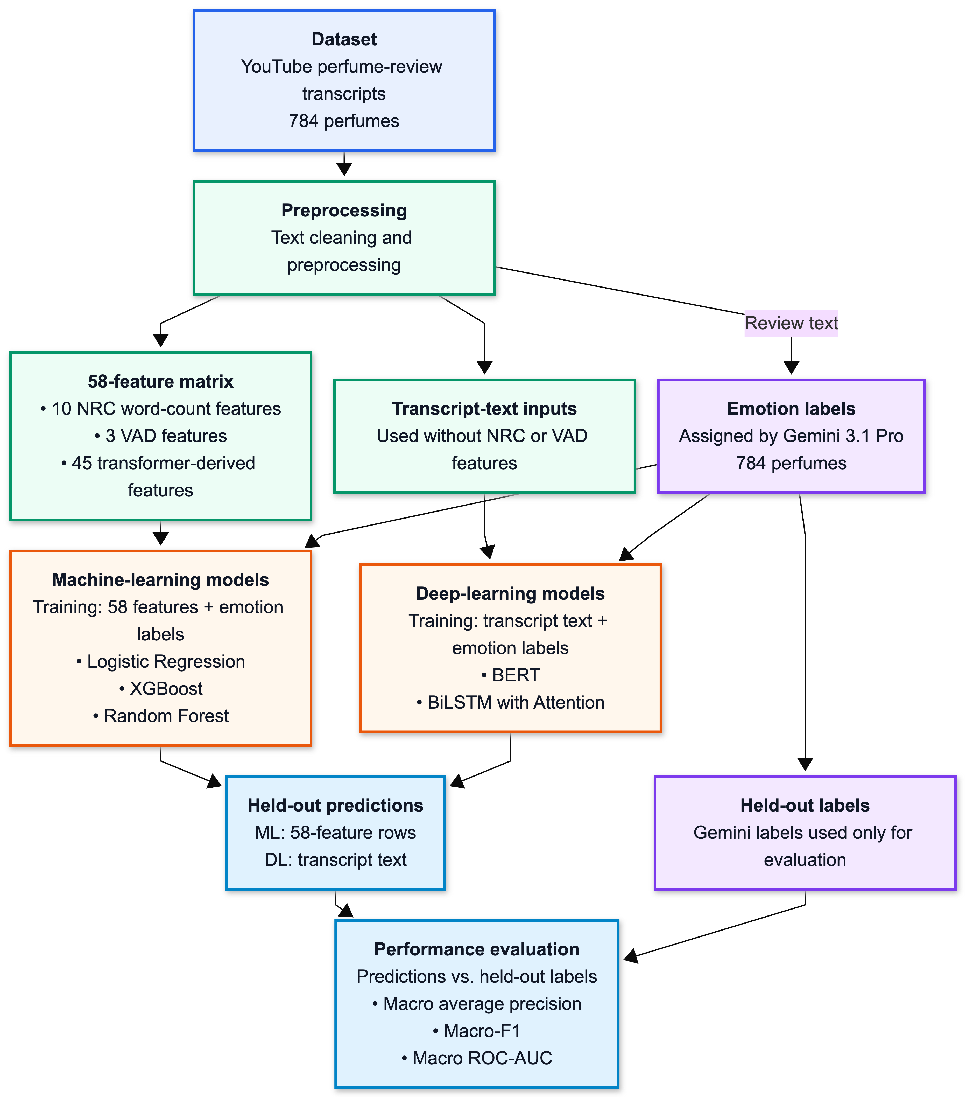
Figure 1: YouTube benchmark pipeline showing the two model-input paths, Gemini emotion labels, held-out predictions, and performance evaluation.

3.2 DATASET CONSTRUCTION

3.2.1 YouTube Transcript Benchmark Dataset
The main dataset was constructed from YouTube perfume-review videos. The collection code searched YouTube through the YouTube Data API using perfume-oriented query templates such as perfume name plus review, perfume, or fragrance terms. For each returned video, the pipeline stored the video identifier, title, description, URL, channel title, transcript text, transcript length, and the final formatted transcript. Transcript text was then retrieved from the available English YouTube caption/transcript stream through the transcript API used in the project code.
A review row was included only when a video could be found, an English transcript or caption could be retrieved, and the resulting transcript contained at least 20 words. Rows with unavailable transcripts, disabled transcripts, missing English captions, API or quota failures, or transcripts below the minimum length were not included in the final raw transcript table. The code did not store whether a caption was manually created or automatically generated by YouTube. Therefore, the dataset is described as available English YouTube caption/transcript text rather than as a fully manual transcript corpus.
The official benchmark was finalized with 4,881 usable review-level transcript rows covering 784 unique perfumes. This is the source table used for source grouping and perfume-level feature aggregation. For the transcript-only BERT and BiLSTM inputs, two within-perfume rows with duplicate Final Transcript text are removed, leaving 4,879 chunks while retaining all 784 perfumes. The number 4,881 therefore denotes usable raw source rows, whereas 4,879 denotes the final deduplicated transcript-only chunks; neither count is a perfume count. The raw review table contains one to ten rows per perfume, with a median of seven. The official supervised benchmark still uses one aggregated feature row and one set of model-based reference labels per perfume.
During incremental collection, the collection script checks the pair of normalized perfume name and YouTube video identifier before appending a row, so the final raw file contains no duplicate perfume-video pairs. A video identifier can still appear under more than one perfume when a single review video discusses multiple fragrances; such cases differ from repeated rows for the same perfume-video pair and are therefore retained. Table 1 summarizes the final YouTube benchmark and the separate synthetic dataset used in the extension.

Table 1: Overview of the YouTube and synthetic datasets
Dataset component | Count / status
Candidate perfume catalog | 2,191 rows; 2,184 unique perfume names
Processed collection summary | 1,330 perfumes processed: 784 usable, 533 no videos, 13 no results
YouTube transcript inputs | 4,881 usable raw transcript/caption rows; 4,879 transcript-only chunks after two within-perfume exact duplicate Final Transcript rows were removed
Supervised benchmark | 784 perfumes; one final feature row per perfume
Review coverage | 1–10 transcript rows per perfume; median 7; mean 6.226
Synthetic dataset | Primary corpus: 2,352 labeled rows (784 perfumes × 3 reviews, indices 1–3); separate exploratory extended corpus: 4,704 total rows (784 perfumes × 6 reviews: the primary corpus plus 2,352 add-on rows for review indices 4–6)

Table 2 follows four actual YouTube review rows through review-level feature extraction. NRC counts and VAD means are calculated from the complete stored Final Transcript after the text is formatted, lowercased, and tokenized. The four pretrained transformer scripts instead classify only the first 512 characters of that transcript. The second column reproduces this exact text so the transformer labels can be read alongside the input that produced them.

Table 2: Four YouTube reviews and their review-level feature-extraction outputs.
Perfume and YouTube video | Text sent to the transformer models (first 512 characters) | NRC and VAD output from the complete transcript | Transformer top labels for the displayed text
Table 2 Continued: Four YouTube reviews and their review-level feature-extraction outputs.
vetiver oriental eau de parfum — 209T3K9tNp4 — Vetiver Oriental by Serge Lutens fragrance/cologne review | “hello Fram here so today I'm coming with a review on V oal so what do I get out of V oal so at the opening I get a medicinal uh vver and Iris note to people around you they just smell something light and green um but uh when you bring it up close and then smell it up close um you do get the medicinal Vibe um so after a few minutes you get the oakmoss that comes in and gives it even medicinal more medicinal Vibe so you get a little bit of B addition to the medicinal that and Iris not so after 10 minutes that” | 717 tokens. Highest NRC counts: positive 26, trust 26, anticipation 22. Mean VAD: (0.131, −0.102, −0.016). | Top labels: Hartmann neutral; Savani joy; GoEmotions neutral; Cardiff optimism.
Table 2 Continued: Four YouTube reviews and their review-level feature-extraction outputs.
tabacco toscano cologne eau de cologne — XuUuSqEWjCU — Tabacco Toscano - Santa Maria Novella Short vanilla fragrance review | “vanilla is not the diva here it's not the main note but I definitely smell it a lot and together with the smokiness of the tobacco something green and something Woody M it's so great for those people who don't like sweet vanilla but you still want something with a touch something with a little bit of sweetness you know something that will give you that vanilla mood perfect just try this it's so great it will not suffocate you because it's a low concentration so you can refresh it all the time not something ” | 120 tokens. Highest NRC counts: positive 9, trust 7, joy 5. Mean VAD: (0.163, −0.122, 0.026). | Top labels: Hartmann neutral; Savani joy; GoEmotions approval; Cardiff optimism.
Table 2 Continued: Four YouTube reviews and their review-level feature-extraction outputs.
boccanera parfum — C-xVeCVn06M — CHOCOLATE SEDUCTION - BOCCANERA by ORTO PARISI | “[Music] [Applause] [Music] hello everyone marcelo with my name i am the niche fragrance collector and i need to well i need to confess really quickly and that is i am a huge fanboy of alessandro gauthieri so that makes me unreliable when it comes to being objective about any of his work so if you're coming here to get a balanced feedback unfortunately you're just going to get a very biased view on the the stuff that he does i love his nasomato i've got the full range and i love his orto parisi also have his” | 1,492 tokens. Highest NRC counts: positive 76, trust 49, joy 46. Mean VAD: (0.150, −0.060, 0.034). | Top labels: Hartmann neutral; Savani sadness; GoEmotions love; Cardiff optimism.
Table 2 Continued: Four YouTube reviews and their review-level feature-extraction outputs.
remarkable people eau de parfum — hCmM7rzRZWM — REMARKABLE PEOPLE by Etat Libre d'Orange. ASMR perfume review | “welcome to my quite unusual perfume review channel i draw or paint what i smell and what a certain fragrance reminds me of i've spent the last week wearing one particular perfume from italy bredohans discovery said remarkable people the official booklet states that this olfactory creation is dedicated to un-people uncompromising unexpected unconventional unpredictable we're off to a very vivid and promising start but what does it really smell like remarkable people was released in 2015. it's light but sophi” | 1,061 tokens. Highest NRC counts: positive 59, trust 42, joy 30. Mean VAD: (0.158, −0.106, 0.002). | Top labels: Hartmann surprise; Savani surprise; GoEmotions excitement; Cardiff optimism.

The values in Table 2 are intermediate review-level outputs, not final model predictions. NRC records word-category counts across the complete transcript, and VAD summarizes the words matched in that complete text. Each transformer label is the highest-probability category for the displayed 512-character input; the complete probability vector from that inference is retained in the feature files. All usable reviews for the same perfume are then aggregated into one 58-feature row for Logistic Regression, XGBoost, and Random Forest. BERT and BiLSTM with Attention instead use the cleaned transcript chunks directly. The Gemini annotation example in Section 3.4 remains separate because it demonstrates how target labels are assigned, while Section 3.8 follows one perfume through aggregation and final prediction.

3.2.2 Synthetic Dataset Expansion
The synthetic reviews were created after the YouTube benchmark was fixed and were kept as a separate data branch. RQ3 examines whether weighted synthetic augmentation changes multi-label emotion classification on held-out YouTube perfumes. The completed formal analysis applies the fixed weighted 784×3 condition (three generated reviews per perfume) to Logistic Regression, XGBoost, Random Forest, BERT, and BiLSTM with Attention. The protocol was frozen first for Logistic Regression and then applied as model-specific extensions before the other four formal runs. Synthetic-only, 784×6, review-count sweep, and alternative balancing results remain exploratory. Prior work has created text augmentations through controlled edits and LLM-based rephrasing [37], [38]. In this thesis, the synthetic branch is evaluated against an unchanged YouTube test set rather than assumed to improve performance.
In this thesis, a synthetic review consists of generated perfume-review text rather than text from a real YouTube review. Each row includes a perfume name, a unique review ID, review text in the same Final Transcript format, and metadata describing how the review was generated. Keeping the main fields compatible allows both datasets to use the same preprocessing and feature extraction. For the structured models, natural reviews are aggregated into one feature row per perfume, while synthetic reviews remain separate training rows.
GPT-5 generated three synthetic reviews for each perfume using predefined scenario sentences and details about the perfume’s scent and usage context [39]. The project used a template-guided process based on the same 784 perfume identities as the YouTube benchmark, local sensory and context keywords, persona settings, style families, and scenario templates. Existing emotion and VAD labels from the perfume identity source were explicitly ignored during generation. This design avoids label conditioning: the generated text was not written by directly inserting the target emotion labels that the supervised models would later try to predict.
Nearby words around selected emotion terms in the YouTube transcripts were used only to identify natural sensory and contextual language for GPT-5's template-guided synthetic-review generation. These context terms were not included in the 58-feature matrix or used as model inputs; Figure 2 illustrates this supporting extraction step.

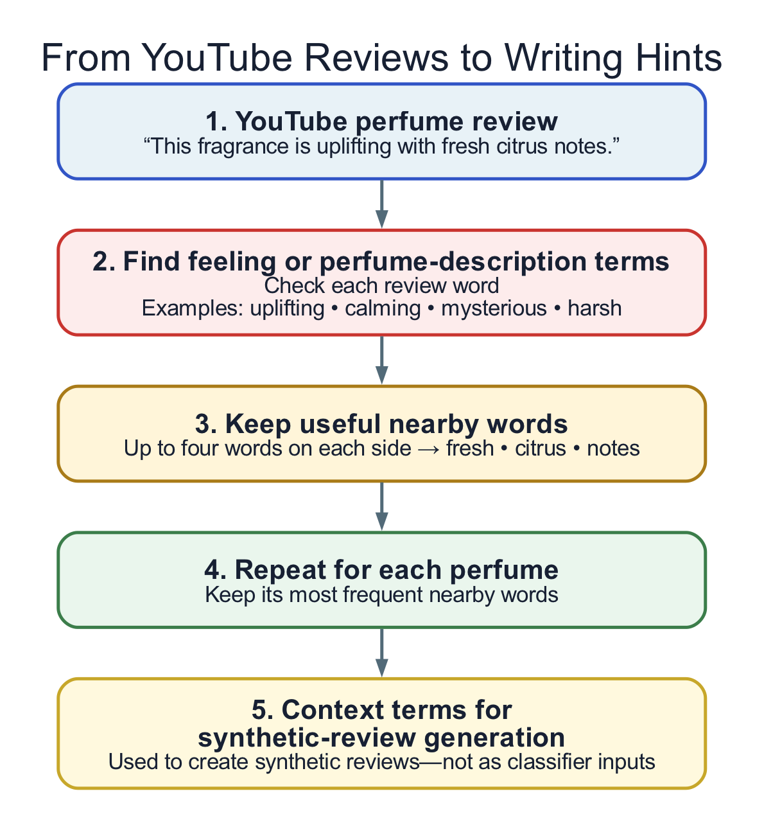
Figure 2: Extraction of perfume-specific writing hints from YouTube review context.

The synthetic files also include generation-tracking columns that describe how each row was generated. These columns support auditing but are never model features. In the structured-input branch, NRC, VAD, and transformer-derived features are extracted from the synthetic review text for Logistic Regression, XGBoost, and Random Forest. BERT and BiLSTM with Attention instead consume the synthetic review text directly. The generator also checks unique review identifiers, non-empty Final Transcript values, and the absence of emotion or VAD label columns from the generated-text file.
The primary augmentation corpus contains 2,352 labeled review rows: review indices 1–3 for each of the 784 perfume identities. A separate extended 784×6 corpus contains 4,704 total rows by combining the primary 2,352 rows with 2,352 add-on rows for review indices 4–6. The extended corpus is retained only for exploratory synthetic analyses; its 4,704 rows are a total, not an additional set, and it is not the primary augmentation corpus.
After GPT-5 generated the synthetic reviews, Gemini 3.1 Pro assigned model-based reference labels through the structured browser workflow. Gemini was not used for generation. Generation and labeling used different models. The resulting labels served as a consistent reference for evaluating all five models. The base-weight design gives each natural training perfume total weight 1 and each of its three synthetic reviews weight 1/3. For the structured models, the weights enter model-specific preprocessing or classifier fitting; for BERT and BiLSTM, natural chunks are normalized to total base weight 1 per perfume and the weights enter the training loss. For all models, synthetic reviews linked to test perfumes are excluded. BERT and BiLSTM also exclude those linked to their inner-validation perfumes. Final testing uses only held-out YouTube perfumes.

3.3 DATA PREPROCESSING
The preprocessing stage prepares noisy transcript data for later feature building and evaluation. It standardizes perfume identifiers, normalizes whitespace and line breaks, removes formatting artifacts where applicable, and creates a consistent text version for each review. The goal is not to rewrite the reviewer’s language. Perfume reviews use language to express perceptions and opinions of fragrance [2], while metaphor and surrounding context can carry affective meaning [35], [36]. Context-aware normalization should therefore preserve the intended meaning of the text [40]. In this thesis, preprocessing creates a stable text input that can be reused by all later stages.
At the code level, transcript cleaning changes only the formatting of the text, not the language itself. The formatting script requires both Transcript and Final Transcript columns, replaces line breaks with spaces, collapses repeated whitespace, and removes leading and trailing whitespace. The collection code also normalizes transcript text by replacing carriage returns and newlines with spaces and joining split tokens into one clean string. This preserves the reviewer's original wording for feature construction and for the transcript-text models, including metaphors, intensifiers, hesitations, and informal speech.
A single cleaned transcript table is treated as the official input to every downstream feature stage. The lexicon, transformer, and supporting context-term stages all read the same canonical transcript field, preventing feature families from being calculated from different versions of the review text. Exact filenames, scripts, and paths are listed in Appendix 1.
Daily-language filler words and general stopwords are retained in the canonical transcript so that the original sentence context is preserved. This matters when affect is expressed indirectly or through surrounding context [35], [36]. The direct-text models also learn from word sequence and context [25], [31], [32]. The NRC and VAD stages use only words found in their lexicons, so retained non-matching words do not change those feature values. Filtering is therefore confined to the supporting contextual scent-term analysis, where it makes descriptive term lists easier to inspect without altering the supervised feature matrix.
Missing and empty transcript handling occurs mainly before aggregation. A row is written to the final raw transcript file only if transcript text is retrieved and the cleaned transcript contains at least 20 words. Videos with no retrievable English transcript, disabled or missing captions, transcript retrieval errors, API or quota failures, or too-short text are not included as usable review rows. The benchmark file therefore contains 4,881 non-empty Final Transcript rows. Because empty transcript rows are removed before modeling, the pipeline does not need to guess or fill in missing transcript text later.

3.4 LLM-ASSISTED EMOTION ANNOTATION AND REFERENCE LABELING
The supervised benchmark needs target labels. Full human annotation would have required multiple annotators, formal guidelines, adjudication, and agreement analysis; prior work also notes the cost, subjectivity, and quality-control difficulties of human emotion annotation [20]. This was beyond the project scope. Gemini 3.1 Pro [19] was therefore used through a structured browser workflow. Studies of LLM-assisted emotion annotation and related affective tasks provide methodological precedent [21]–[23]. The model followed a fixed prompt and schema and produced the reference labels used for supervised evaluation.

The labels produced by Gemini 3.1 Pro are used as the reference labels throughout the thesis. They provide a common target for training and evaluating all five models. Since they are model-generated rather than human annotations, the evaluation measures how well the models reproduce this labeling approach. Figure 3 shows how the labels are created, checked, and prepared for use.

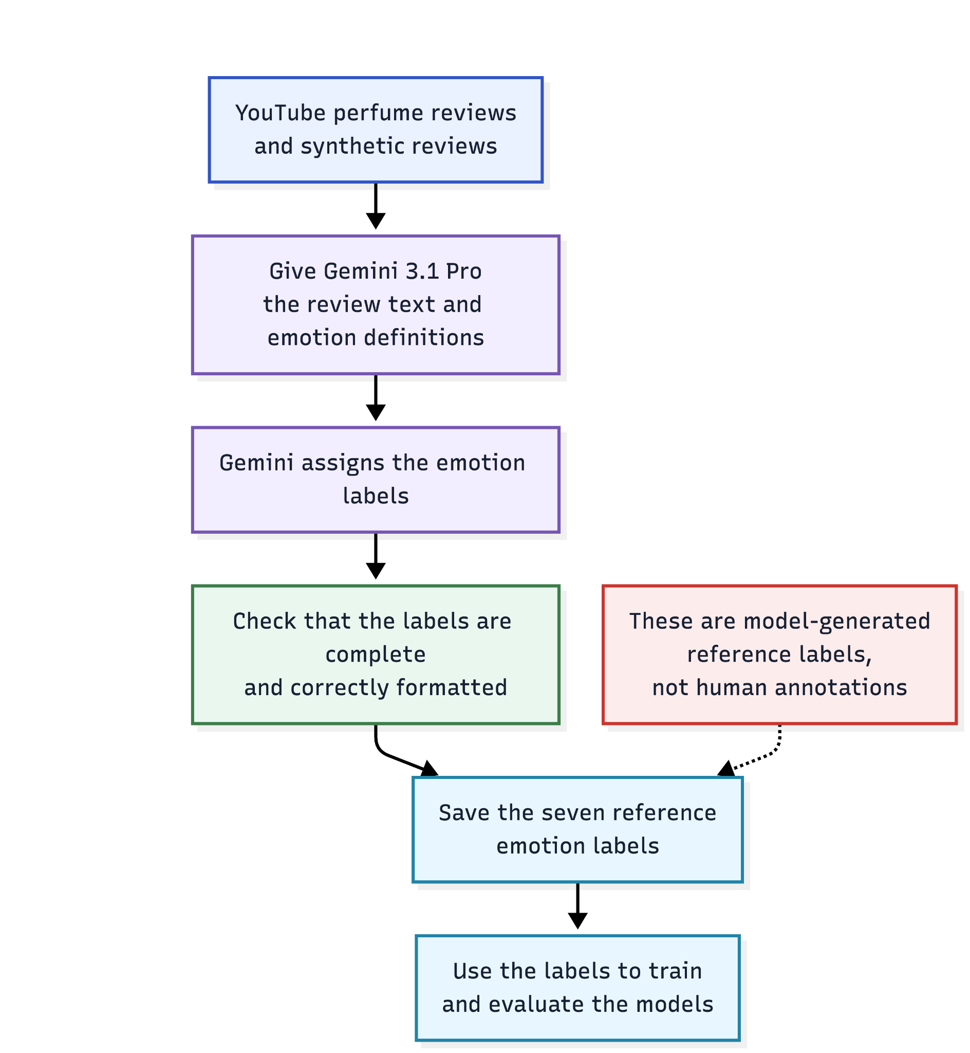
Figure 3: How Gemini 3.1 Pro is used to create the reference emotion labels.

The labeling unit differs between the two datasets. Each YouTube perfume receives one set of reference emotion labels, whereas each synthetic review receives its own labels. The validated outputs are then converted into tables with consistent emotion columns for model training and evaluation.
For each YouTube perfume, the browser packet included identifier fields and preserved one or two source chunks: 736 items had two excerpts and 48 had one. Each excerpt was limited to 360 characters, including any retained source prefix. Identifier fields were copied into the packet to preserve row identity, but the prompt required labels to be assigned only from the supplied excerpts rather than from those identifiers.
The fixed browser prompt applied the evidence, label, VAD, neutral-fallback, and output rules summarized below. The complete YouTube perfume-level and synthetic review-level prompt texts, including their exact output schemas, are reproduced in Appendix 3.

Table 3: Important annotation rules retained in the methodology
Prompt element | Operational rule
Unit | YouTube items are labeled at perfume level; synthetic items are labeled at generated-review level.
Evidence | Use only the supplied review text or excerpts; do not infer from brand, perfume name, reputation, note list, marketing concept, or niche status.
Emotion | Assign independent binary labels only when clear linguistic evidence is present; multiple emotions may be active.
VAD | Score valence, arousal, and dominance from 1 to 9; arousal means emotional activation and dominance means confidence or control, not perfume strength.
Neutral fallback | If emotional evidence is weak or neutral, set all emotion labels to 0 and use valence = 5, arousal = 5, dominance = 5.
Output | Return the required CSV schema and batch tracking line without markdown or explanation.

The following verified example shows how the fixed prompt was applied. The same perfume is traced through feature extraction and prediction in Section 3.8.

Table 4: Worked annotation example
Example part | Verified content
Prompt instruction | “Use ONLY the review excerpts provided. Set an emotion to 1 only when there is clear linguistic evidence; otherwise set it to 0. Multiple emotions can be 1. For VAD, judge the overall emotional tone across the excerpts.”
Input | Vetiver Nocturne Absolu Extrait de Parfum; two saved YouTube excerpts. Example from excerpt 2 (shortened for display): “I saved them but I appreciate that ... what did you want to try first ...”
Returned emotion labels | joy=1; sadness=0; anger=0; fear=0; trust=1; surprise=0; anticipation=1; disgust=0
Returned VAD | valence=7; arousal=5; dominance=5

Returned annotation files were checked for the correct CSV header, row count and order, matching item identifiers, duplicate identifiers, binary emotion values, and VAD integers from 1 to 9. Only validated outputs were converted into pipeline-ready label and report files for model training.
Anger remains in the annotation schema for completeness, but it is excluded from official benchmark reporting because its positive support is too limited for stable evaluation across the 784-row benchmark branches. The official model comparison therefore uses the other seven emotion labels.

3.5 FEATURE EXTRACTION
Feature extraction in this section creates the inputs used by Logistic Regression, XGBoost, and Random Forest. BERT and BiLSTM with Attention use cleaned transcript text instead. The 58-feature matrix combines six families: NRC, VAD, Hartmann, Savani, GoEmotions, and Cardiff. NRC and VAD provide lexicon-based signals, while the four transformer-derived families provide contextual emotion probabilities. The contextual scent-term analysis supports the study of perfume language and synthetic-review generation but is not used as classifier input. Table 5 summarizes the six feature families.

Table 5: Feature families used in the 58-feature matrix.
Feature group | Feature family | Feature type | Role in thesis
Lexicon-derived | NRC | 10 lexicon count features | Provides interpretable word-level emotion evidence: anger, anticipation, disgust, fear, joy, sadness, surprise, trust, positive, and negative.
Lexicon-derived | VAD | 3 dimensional affect features | Represents valence, arousal, and dominance as continuous affective signals.
Transformer-derived | Hartmann | 7 transformer probability features | Adds contextual emotion probabilities from a pretrained DistilRoBERTa emotion model.
Transformer-derived | Savani | 6 transformer probability features | Adds a second pretrained emotion-model view of the same review language.
Transformer-derived | GoEmotions | 28 transformer probability features | Adds broader fine-grained emotion information from a GoEmotions-based model.
Transformer-derived | Cardiff | 4 transformer probability features | Adds contextual signal from a model trained for informal social-media emotion detection.

3.5.1 NRC Emotion Features
The NRC feature stage extracts lexicon-based emotion information from the transcript text. The NRC Emotion Lexicon is a word–emotion and word–polarity association lexicon [5] built around eight basic emotion categories [6]. In this thesis, NRC features provide transparent lexical counts that can be inspected and discussed in relation to perfume-review language.
NRC features are not treated as final emotion labels. Because affective meaning can depend on surrounding context and metaphor [35], [36], a lexicon match is used only as an input feature. Comparative work reports that contextual methods can capture linguistic nuances that lexicon-based methods may overlook [26]. For this reason, the thesis combines NRC with transformer-derived features and treats NRC as one transparent feature family within the unified matrix.
The implementation extracts the ten NRC word-level categories used by the project code: anger, anticipation, disgust, fear, joy, sadness, surprise, trust, positive, and negative. The raw review-level NRC values are count features, not normalized probabilities. During aggregation, these counts are summed across all usable review rows for each perfume. Anger is excluded from the official supervised target labels because of near-zero support, but the NRC_anger count can still remain as an input feature because it is part of the lexical feature family.
Review-level NRC counts are retained as an auditable intermediate table. During perfume-level aggregation, their column names receive the NRC prefix, distinguishing lexical counts from the model-based target labels.

3.5.2 VAD Features
The VAD stage represents affect through valence, arousal, and dominance. Valence measures pleasantness, arousal measures activation or intensity, and dominance measures control or power [7]. Perfume reviews can connect scent with the experience and social aspects of wearing perfume [2], while odor research links smell with mood and emotion [3]. These connections motivate the use of VAD dimensions in perfume-review analysis.
In the pipeline, transcript tokens are matched to NRC VAD Lexicon v2.1 entries [47]. Their scores range from −1 to +1 and are averaged at review level and then at perfume level. These lexical VAD features are distinct from Gemini’s 1–9 VAD annotations, which are not used as input features. VAD features are included in the 58-feature matrix used by Logistic Regression, XGBoost, and Random Forest. VAD provides a dimensional representation alongside the categorical emotion features. Relationships between VAD and categorical emotion representations have been examined in mapping studies [41].
The VAD code keeps one review-level valence, arousal, and dominance value for every usable transcript row. If a transcript contains no token matched by the VAD lexicon, the implementation assigns zero for that review-level dimension so the row remains aligned with the rest of the pipeline. This zero value is a computational fallback for missing lexical matches, not a claim that the review is emotionally neutral in a human sense.
Review-level VAD scores are retained as an auditable intermediate table. During perfume-level aggregation, the three values are averaged and their column names receive the VAD prefix in the unified feature matrix.

3.5.3 Transformer-Derived Emotion Features
The transformer feature stage uses four pretrained emotion checkpoints: Hartmann, Savani, GoEmotions, and Cardiff. The Hartmann, Savani, and Cardiff checkpoints are documented in their model cards [10]–[12], and the exact GoEmotions checkpoint is documented in its project repository [13]. The GoEmotions dataset and TweetEval benchmark underlying the latter two feature families are described in [9] and [27], respectively. These models are used as feature generators rather than as final thesis classifiers. BERT-style representations process words in their surrounding context [25], while lexicon-based methods can miss context-sensitive meanings [26]. The thesis therefore includes both feature families in the unified matrix.
Emotion datasets differ in domain, label inventory, and annotation scheme [42]. The four transformer feature groups therefore reflect different training domains and emotion vocabularies. The thesis does not assume that any one pretrained model is correct for perfume discourse; their outputs are combined as contextual signals in the constructed feature matrix.
The Hartmann feature family uses an English DistilRoBERTa emotion classifier [10]. The Savani feature family uses a fine-tuned DistilBERT emotion classifier [11]. The GoEmotions feature family uses the monologg/bert-base-cased-goemotions-original checkpoint [13], based on the fine-grained GoEmotions label set [9]. The Cardiff feature family uses a social-media-oriented RoBERTa emotion checkpoint [12], which is based on TweetEval’s tweet emotion-recognition task [27]. These features appear in the final matrix with separate prefixes so they can be audited and interpreted by feature family.
All four transformer feature generators, Hartmann, Savani, GoEmotions, and Cardiff, receive only the first 512 characters of each formatted transcript, not the complete transcript. The limit is character-based, as implemented by slicing the text string before inference. Table 2 shows the exact 512-character inputs for four examples. In contrast, NRC and VAD features are calculated from the complete transcript. Therefore, text appearing after the first 512 characters does not affect the four transformer feature groups.
Each transformer feature generator returns emotion probability scores for every review. When a perfume has multiple reviews, the scores are averaged to create perfume-level features. The highest-probability label is stored separately for inspection, while only the numeric probability scores enter the 58-feature matrix. Exact runner and artifact names are listed in Appendix 1.

3.5.4 Perfume-Level Aggregation Rules
The review-level rows are aggregated to perfume level because the supervised benchmark is defined over perfumes, not isolated review fragments. The NRC stage first converts each final transcript to lowercase and splits the text into word-like tokens. In the code, this is done with the regular expression \b\w+\b, which extracts individual word units from the transcript text. For each matched token, the script increments every NRC emotion category associated with that word. These review-level NRC counts are then summed by perfume. Summing is appropriate for NRC because the values are discrete lexical evidence counts; if multiple reviewers use emotion-associated words for the same perfume, the aggregate count preserves that repeated evidence.
The VAD stage uses the same token stream but treats valence, arousal, and dominance as continuous affective dimensions. For each review row, matched VAD entries are collected and averaged separately for valence, arousal, and dominance; if no VAD token is matched, the script assigns zero for that review-level dimension. At the perfume level, VAD values are averaged across review rows. Averaging is used because VAD represents affective tendency or tone, not a count of repeated labels.
Transformer-derived emotion signals are also aggregated by perfume. The Hartmann model produces a per-review emotion distribution that is expanded from a dictionary column before aggregation. Savani, GoEmotions, and Cardiff produce per-review numeric score columns directly. In the unified aggregation script, numeric transformer score columns are averaged by perfume and prefixed by model family. The top categorical transformer labels are retained separately by taking the modal label per perfume, but the final 58-feature matrix uses the numeric score/probability columns as model inputs.
Aggregating the reviews at perfume level also prevents data leakage. If reviews were split separately, one review of a perfume could be used for training while another review of the same perfume appeared in the test data. The model could then benefit from seeing the same product twice. Creating one row per perfume and assigning it to a single fold keeps each perfume entirely on one side of the split.

3.5.5 Unified Feature Matrix
After feature extraction and perfume-level aggregation, the six feature families are merged into one perfume-level matrix. It contains 58 numeric features: 10 NRC features, 3 VAD features, 7 Hartmann features, 6 Savani features, 28 GoEmotions features, and 4 Cardiff features. This matrix is the shared structured input for Logistic Regression, XGBoost, and Random Forest. BERT and BiLSTM with Attention instead use transcript-text chunks prepared from the same source rows.
Feature selection in this study follows a fixed rule: all 58 numeric features from the six families are retained. NRC represents emotion-word counts, VAD describes affective tone, and the four transformer models provide emotion scores. These families were chosen to compare different ways of representing emotion in review text. No automatic ranking or filtering of individual features is applied.
Only numeric columns belonging to these families are used as predictors. Perfume names, identifiers, categorical top-label fields, and reference labels are excluded. For example, NRC_joy is an input calculated from the review text, while joy is the reference label that the model learns to predict. All feature categories are retained, even when they do not match the seven target emotions.
Within each fold, missing values are filled using training-set medians. Logistic Regression also standardizes the features using training-set statistics. In the augmented condition, this step uses the training sample weights. Random Forest and XGBoost use imputation without standardization. The fitted preprocessing is then applied to held-out data.
The ablation study in Section 4.5.1 compares NRC, VAD, and the combined transformer features. It evaluates each group alone, each pair of groups, and all groups together. This shows how the groups contribute to prediction. It does not identify an optimal subset of individual features.
Figure 4 shows one complete stored row from the unified feature matrix for Vetiver Nocturne Absolu Extrait de Parfum. Parts 1–3 list the 58 numeric model inputs by feature family. The four categorical top-label columns shown at the end are retained in the artifact for interpretation and are not part of the 58-feature input.

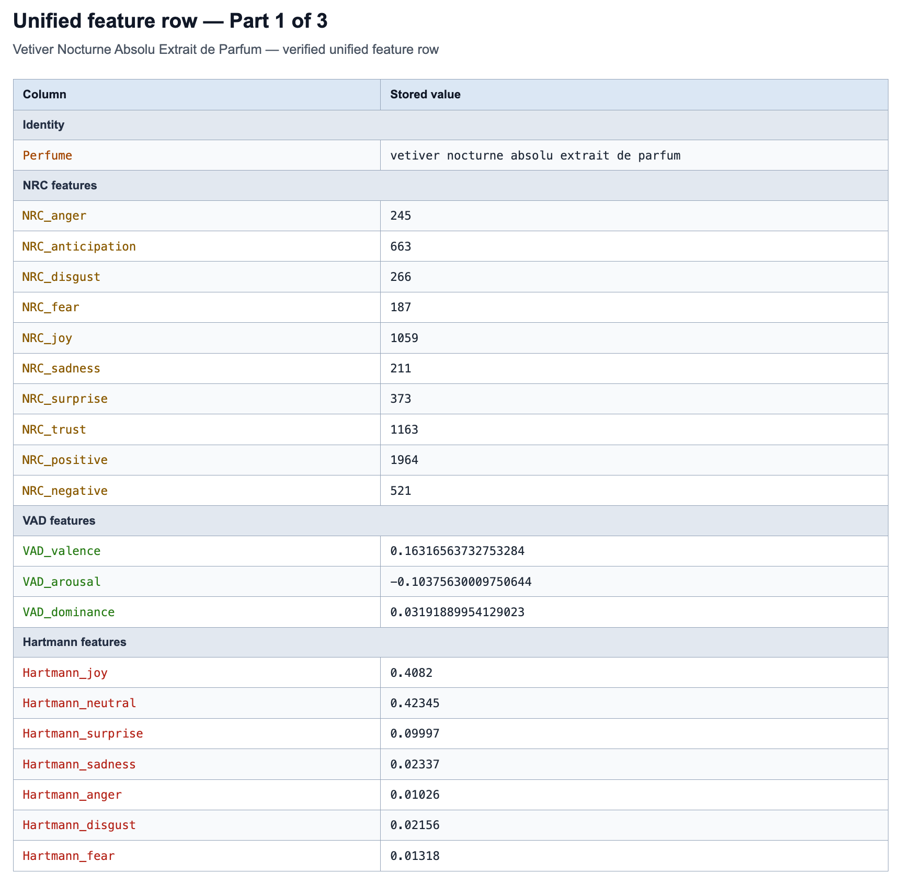
Figure 4: Complete unified feature-matrix row for Vetiver Nocturne Absolu Extrait de Parfum, presented in three panels.
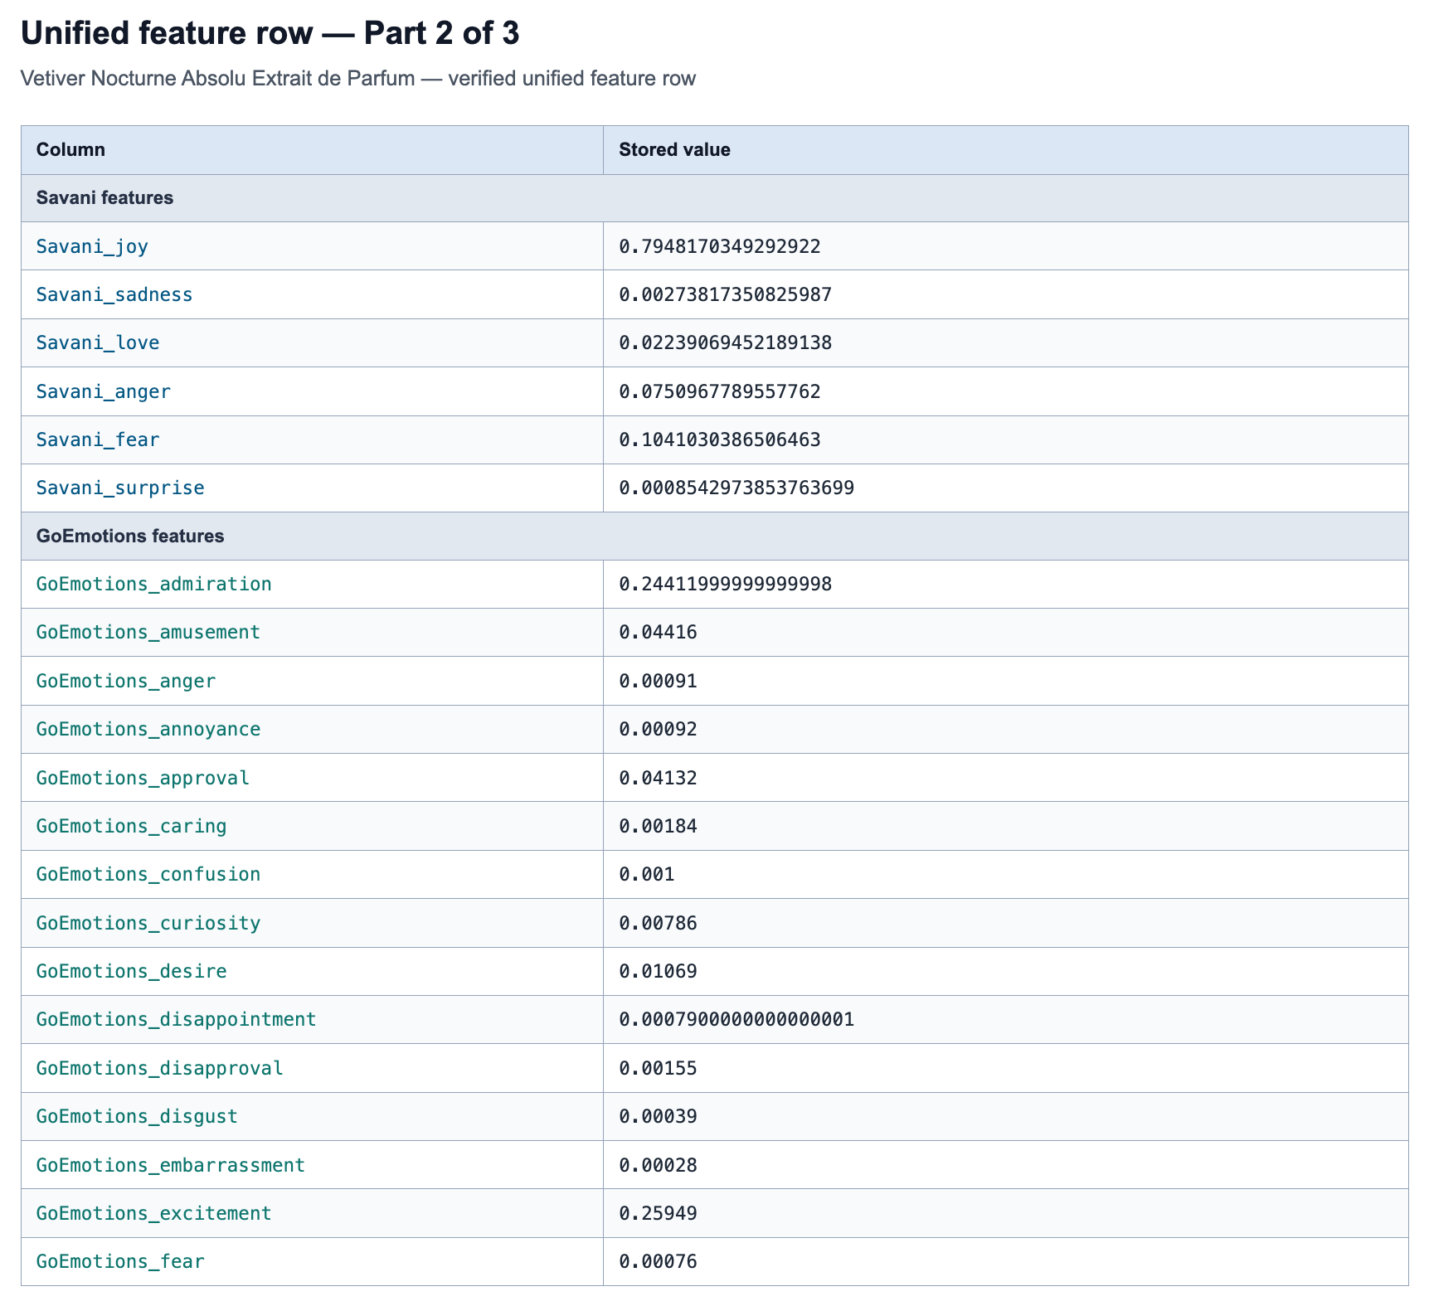
Figure 4 Continued: Complete unified feature-matrix row for Vetiver Nocturne Absolu Extrait de Parfum (Panel 2 of 3).
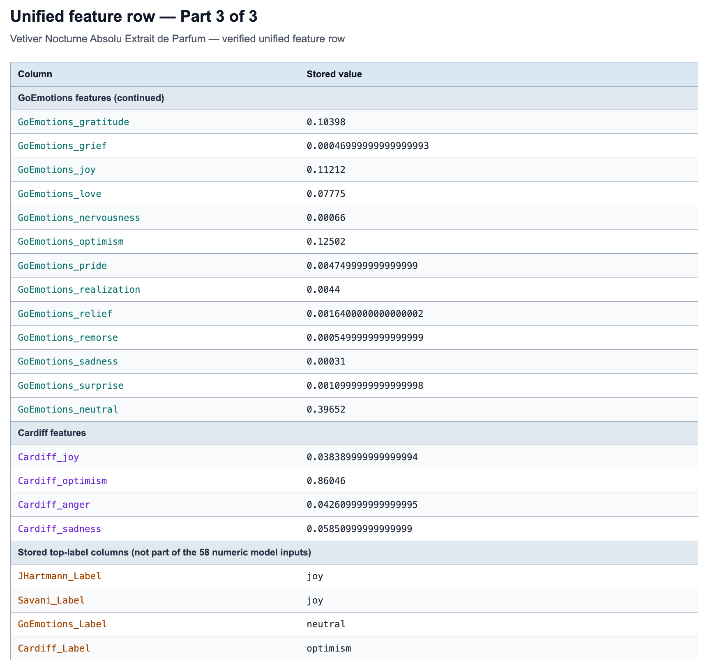
Figure 4 Continued: Complete unified feature-matrix row for Vetiver Nocturne Absolu Extrait de Parfum (Panel 3 of 3).

3.6 MACHINE LEARNING AND DEEP LEARNING MODELS
The study compares five models for predicting emotions in perfume reviews: Logistic Regression, XGBoost, Random Forest, BERT, and BiLSTM with Attention. Each model produces a prediction for each of the seven emotion labels, allowing a perfume to receive more than one label [43]. Table 6 summarizes the models and their input representations.
The models follow two input paths. To preserve a clear comparison between feature-based classification and direct representation learning from text, BERT and BiLSTM with Attention use transcript-text chunks without additional NRC or VAD inputs, whereas Logistic Regression, XGBoost, and Random Forest use the constructed 58-feature matrix. All five use the same reference labels and source-grouped folds.
All five models use the same 784 perfume labels and source-grouped outer test folds. Logistic Regression, XGBoost, and Random Forest fit on the full outer-training portion. BERT and BiLSTM reserve a shared inner-validation subset for early stopping and fit on the remaining inner-training data. Model-specific settings were fixed for the final benchmark as moderate-capacity configurations that balance learning ability, overfitting risk, and available computation. They were not selected by examining the held-out outer-fold results.
The five models were selected to evaluate the constructed inputs across complementary learning approaches. Logistic Regression provides a linear probabilistic classifier [28]. XGBoost is a tree-boosting system [29], and Random Forest is an ensemble of randomized tree predictors [30]. BERT uses pretrained bidirectional contextual representations [25]. BiLSTM with Attention combines LSTM memory [31], bidirectional sequence processing [32], and learned attention [33]. Together, they provide a broad comparison of classical and deep-learning methods.
For the two deep-learning models, BERT and BiLSTM with Attention, the input is transcript text. Their dataset starts from the 4,881 source rows. Removing two exact duplicate Final Transcript rows within perfumes leaves 4,879 chunks and all 784 perfumes. For each YouTube transcript, the script selects a window of about 160 words near the first perfume-name match. If no full-name match is found, it looks for a distinctive word from the name. If neither is found, it uses the beginning of the transcript. BERT and BiLSTM then apply their model-specific token limits. Titles, descriptions, URLs, and channel metadata are retained for auditing but excluded from the model text. Chunk probabilities are averaged into one probability per perfume and emotion.
The feature-group ablation for the three structured-input models is reported in Section 4.5.1.
Table 6: Supervised models used in the evaluation.
Model | Input representation | Purpose
Logistic Regression | 58-feature matrix | Linear classifier for the constructed feature matrix.
Table 6 Continued: Supervised models used in the evaluation.
Model | Input representation | Purpose
XGBoost | 58-feature matrix | Boosted-tree classifier for nonlinear feature relationships.
Random Forest | 58-feature matrix | Ensemble-tree classifier for the constructed feature matrix.
BERT | Transcript-only text chunks | Pretrained transformer for contextual transcript modeling.
BiLSTM with Attention | Transcript-only text chunks | Attention-based recurrent model for transcript sequences.

3.6.1 Logistic Regression
In the YouTube-only benchmark, Logistic Regression is trained separately for each official emotion. Missing feature values are filled with the current training fold's median, and the features are standardized using parameters learned from that training fold. The implementation uses scikit-learn LogisticRegression with solver="liblinear", L2 regularization, C=1.0, max_iter=2000, class_weight="balanced", and random_state set to the training seed. Training uses the five seeds described in Section 3.7. A probability of at least 0.3 produces a positive prediction under the prespecified threshold.
These settings were fixed before the shared evaluation to provide one reproducible Logistic Regression configuration. Because each emotion is fitted as a separate binary target, the same configuration is applied seven times within each fold. Median imputation, scaling, and class balancing are fitted only on the current training fold. The threshold of 0.3 was also fixed before evaluation and applied consistently to all models.
The Logistic Regression arm of the weighted synthetic comparison retains the accepted class-weighted configuration. Its YouTube-only control and augmented condition use identical features, folds, model settings, and threshold; only the permitted synthetic training rows and their weights differ. In its augmented folds, each natural perfume-level feature row has base weight 1, while the three permitted synthetic feature rows have weight 1/3 each; these weights enter both standardization and classifier fitting.

3.6.2 XGBoost
XGBoost tests whether nonlinear interactions between features improve classification. A separate classifier is trained for each emotion. Missing values are filled with medians from the current outer training fold. The model uses 300 trees, max_depth=4, learning_rate=0.05, subsample=0.9, colsample_bytree=0.8, and histogram tree construction. Training uses the five seeds described in Section 3.7. For each label, scale_pos_weight is the ratio of negative to positive examples in that training fold. This gives rare positive examples more weight without using test-fold labels. The YouTube-only control uses the same settings. In augmented training, each permitted synthetic feature row has a base weight of 1/3. These weights are used during fitting. The class ratio is calculated from the total weights of the positive and negative examples.

3.6.3 Random Forest
Random Forest combines randomized decision trees [30] and uses the constructed feature matrix. Missing values are filled with training-fold medians. The model uses 500 trees and class_weight="balanced_subsample". Training uses the five seeds described in Section 3.7. The YouTube-only control uses the same settings. In augmented training, each permitted synthetic feature row has a base weight of 1/3. These weights are used during fitting alongside balanced-subsample class weighting.

3.6.4 BERT
BERT uses the monologg/bert-base-cased-goemotions-original checkpoint [13], based on the fine-grained GoEmotions label space [9]. The maximum sequence length is 96, the learning rate is 2e-5, and weight decay is 0.01. Training lasts up to three epochs, with an early-stopping patience of one epoch. Early stopping uses the source-isolated inner validation set within the current outer training fold. Validation Macro-F1 is the primary criterion for selecting the saved epoch. The audited seed-42 YouTube-only predictions are reused. The other four seeds use the same model settings. In each augmented fold, three synthetic reviews are added for each inner-training perfume. Each synthetic review has a base loss weight of 1/3. Natural chunks have a total weight of 1 per perfume. Validation and testing use only YouTube data.

3.6.5 BiLSTM with Attention
The BiLSTM with Attention model is trained from scratch. Its vocabulary is built only from the inner-training chunks within each outer fold using lowercase tokens, a minimum frequency of 2, and at most 20,000 terms. Chunks are limited to 208 tokens. The model uses 96-dimensional embeddings, a 64-unit bidirectional LSTM, a 64-unit attention layer, and dropout 0.3. It may train for up to 12 epochs, with an early-stopping patience of two epochs based only on the inner-validation subset. Validation Macro-F1 is the primary criterion for selecting the saved epoch. The YouTube-only BiLSTM control is replayed under the same fixed protocol. In each augmented fold, three synthetic reviews are added only for inner-training perfumes at base loss weight 1/3 each; natural chunks sum to weight 1 per perfume, and validation and testing remain YouTube-only.

Together, the five models compare how the constructed feature-matrix and transcript-text inputs perform across linear, tree-based, transformer-based, and recurrent architectures.

3.7 DATA SPLITTING AND TRAINING STRATEGY

3.7.1 Source-Grouped Splits and Training Seeds
To prevent information from passing between training and testing, reviews from the same YouTube video or with the same cleaned transcript were kept in the same data group. These groups were divided into five folds, with each fold used once for testing while the remaining folds were used for training. The same folds were used for all five models, and every learned processing step was fitted only on the training data. Synthetic reviews connected to test perfumes were excluded for all models. BERT and BiLSTM also excluded those connected to their inner-validation perfumes. This ensured that each model was evaluated on perfumes and review text it had not used for learning. Figure 5 summarizes the procedure.
Training is repeated with seeds 42, 123, 2026, 7, and 99 for each main condition and structured-feature ablation. A training seed controls random choices such as initialization and training order. The seed values have no special statistical meaning. The data-split seed remains 42, and both the outer folds and inner validation sets stay fixed. This separates variation caused by training from variation caused by changing the data split. Existing seed-42 results are reused only after checking their inputs, settings, and predictions.

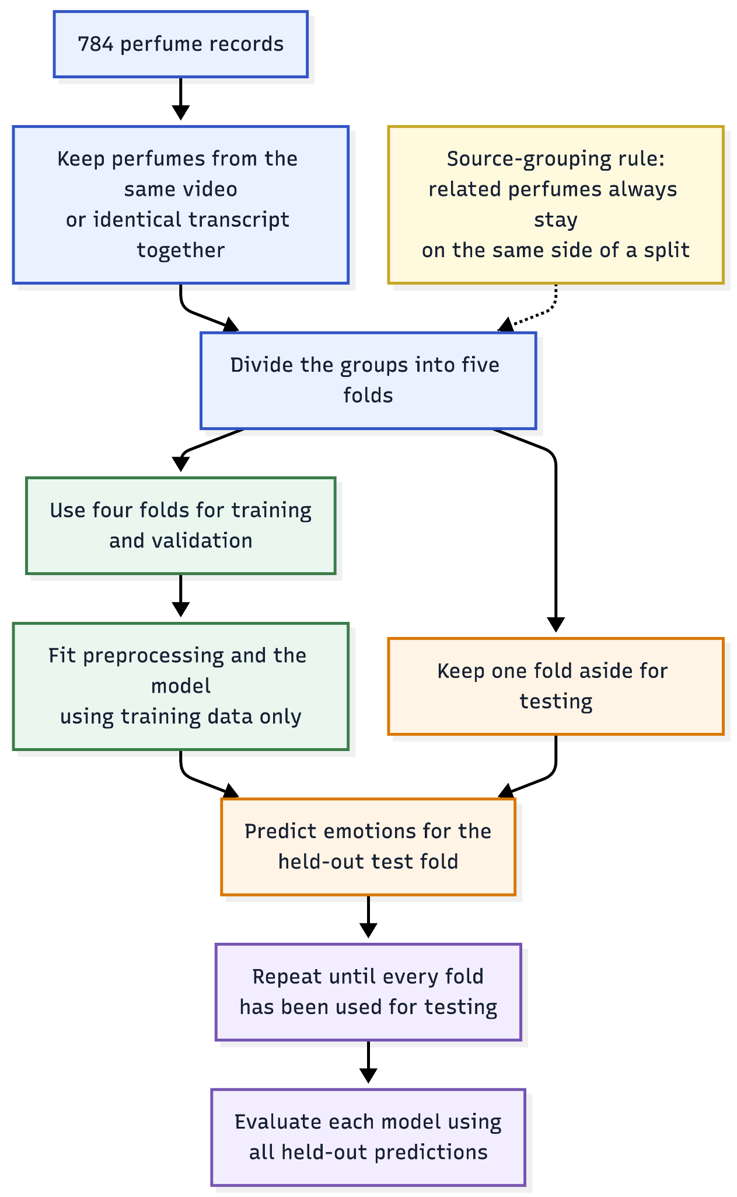
Figure 5: Source-grouped five-fold evaluation process used for all five models.

3.7.2 Synthetic Data in Model Training
The formal synthetic extension evaluates five matched within-model contrasts. Each model has an accepted YouTube-only control and a weighted 784×3 condition, and both are evaluated on the same held-out YouTube perfumes. Target emotion and VAD labels are not used during generation; Gemini 3.1 Pro assigns the seven review-level reference labels afterward. Logistic Regression was the first frozen contrast, and the same comparison logic was frozen for XGBoost, Random Forest, BERT, and BiLSTM with Attention before their formal extension runs.
For each model, the control is trained with YouTube data and the augmented condition adds three synthetic reviews for every permitted training perfume. The two conditions retain the same source-grouped folds, accepted model specification, threshold, and held-out YouTube test set. The three structured models consume extracted features, whereas BERT and BiLSTM consume review text, so augmentation is interpreted as a within-model contrast rather than an identical intervention across model families.
The base-weight rule gives each natural training perfume total weight 1 and each of its three synthetic reviews weight 1/3. The single structured row therefore has weight 1; natural text chunks divide weight 1 across the perfume's chunks. Logistic Regression uses base weights in scaling and fitting, XGBoost and Random Forest use them in classifier fitting, and BERT and BiLSTM use them in the training loss. Model-specific class weighting still applies where defined. Synthetic reviews for held-out test perfumes are excluded for all models; BERT and BiLSTM also exclude synthetic reviews for their inner-validation perfumes.
The main comparisons use the same fixed threshold. The 784×6, SMOTE, hybrid-balancing, synthetic-only, and review-count experiments are exploratory checks. Bootstrap analysis repeatedly resamples the source groups to estimate uncertainty. Intervals for the original seed-42 predictions were estimated using 2,000 paired resampling repetitions. This number was a fixed analysis setting; no sensitivity check was performed to assess whether more repetitions would change the intervals. Each repetition resamples the 359 source groups, using the same sampled groups for both training conditions [44]. The bootstrap seed is also 42. Scores are calculated with all seven labels and then with fear excluded. If a sample contains no positive examples of an emotion, that emotion is left out of the AP average. ROC-AUC requires both positive and negative examples. The 30 resulting intervals are not corrected for multiple comparisons, so they are treated as exploratory evidence [45].
Each YouTube-only run is paired with the augmented run that uses the same training seed. The score difference is calculated for each pair. The five differences are then summarized by their mean and sample standard deviation. Natural inputs are perfume-level feature rows or groups of transcript chunks. Synthetic inputs are individual generated reviews. Each model follows the same base-weight rule but keeps its own input format. Figure 6 shows this design.

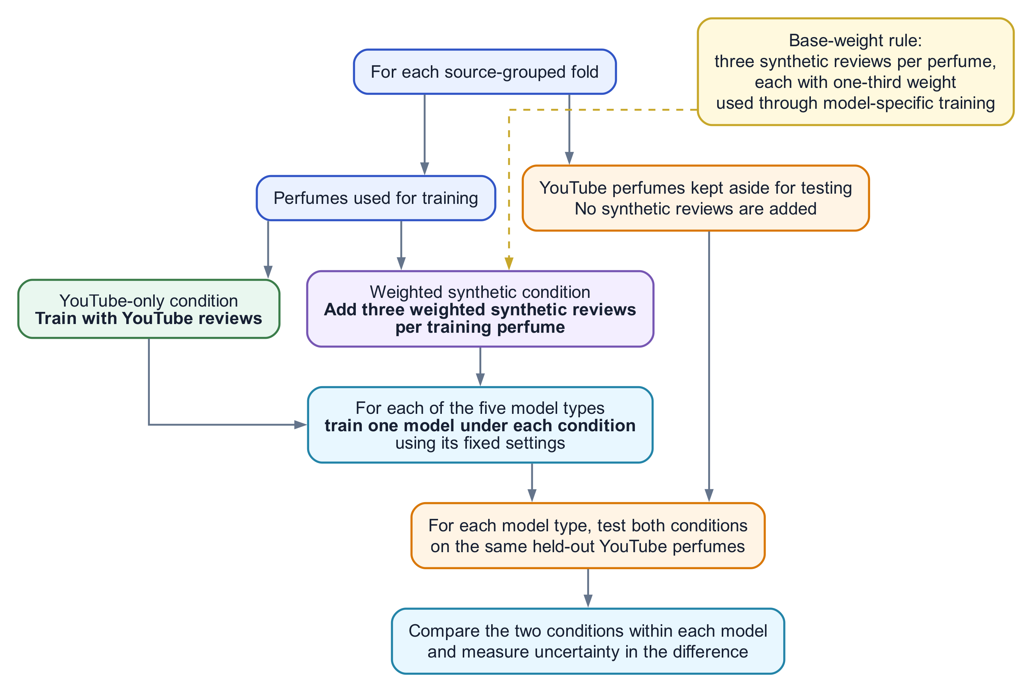
Figure 6: Common YouTube-only and weighted synthetic-training design for five model-specific comparisons on the same held-out perfumes.

3.8 STEP-BY-STEP PIPELINE EXAMPLE
This section follows one perfume through the full pipeline. It shows how its transcripts are turned into features and reference labels, and how the 58-feature input is used to produce a Logistic Regression prediction. Logistic Regression provides one clear example of the structured-input path.
The selected example is “Vetiver Nocturne Absolu Extrait de Parfum”. Its cleaned transcripts, feature values, Gemini 3.1 Pro reference labels, and saved Logistic Regression predictions can all be traced in the project files. Exact filenames and paths are listed in Appendix 1.
At the input stage, this perfume has 10 usable YouTube transcript rows in the 4,881-row raw file. These rows are aggregated into one perfume-level unit using Final Transcript as the canonical transcript column. Under the final evaluation protocol, the perfume belongs to outer fold 4 and to an exact-source component containing four perfumes. Every perfume in that component remains on the same side of the outer and inner splits.

3.8.1 Transcript Excerpt and Feature Values
The short excerpt used for the micro-level trace is “slightly sweet medicinal herbs”. This phrase describes perceived odor qualities rather than background review context. The excerpt-level values below explain token matching; they are not the final perfume-level features, which are computed from all 10 transcript rows.

Table 7: Step-by-step example from a transcript excerpt to the final prediction.
Pipeline point | Value in the example
Excerpt source | The phrase “slightly sweet medicinal herbs” comes from a transcript segment describing the perfume's scent.
Tokenization | The phrase is lowercased and split into four tokens: slightly, sweet, medicinal, herbs.
Excerpt NRC match | The token sweet adds +1 to anticipation, joy, positive, surprise, and trust. The other three tokens add no NRC emotion counts in this excerpt.
Excerpt VAD values | Values are valence, arousal, dominance: slightly (-0.060, -0.452, -0.490), sweet (0.336, -0.164, -0.236), medicinal (0.334, -0.166, 0.228), and herbs (0.240, -0.402, -0.384). The excerpt mean is (0.213, -0.296, -0.221).
Full perfume input | Ten usable YouTube transcript rows are aggregated into one perfume-level row. The perfume is assigned to outer fold 4 inside a four-perfume exact-source component.
Full 58-feature row | Selected features are NRC_positive=1964, NRC_trust=1163, NRC_joy=1059, NRC_anticipation=663, and NRC_negative=521. Full-row VAD is valence=0.163, arousal=-0.104, dominance=0.032.
Table 7 Continued: Step-by-step example from a transcript excerpt to the final prediction.
Pipeline point | Value in the example
Transformer signals | Mode labels are Hartmann=joy, Savani=joy, GoEmotions=neutral, and Cardiff=optimism. Selected aggregate probabilities are Hartmann neutral=0.423 and joy=0.408, Savani joy=0.795, GoEmotions neutral=0.397, and Cardiff optimism=0.860.
Gemini reference labels | Official labels are joy=1, trust=1, anticipation=1, sadness=0, fear=0, surprise=0, and disgust=0. The label file also records anger=0 and Gemini VAD values of valence=7, arousal=5, dominance=5.
Logistic Regression output | The saved Logistic Regression probabilities are joy=0.673850, sadness=0.027227, fear=0.006614, trust=0.603986, surprise=0.019994, anticipation=0.602763, and disgust=0.002589. At threshold 0.3, the positive predictions are joy, trust, and anticipation.

3.8.2 Prediction Results for the Example Perfume
Table 7 provides the compact perfume-level artifact trace. The expanded artifact-to-prediction workflow is retained for reproducibility in Appendix 1 as Figure 9.
Figure 7 shows the seven Logistic Regression probabilities for the example perfume. The threshold is 0.3, so joy, trust, and anticipation are predicted as positive. The other four probabilities are below 0.03, including disgust at 0.002589.

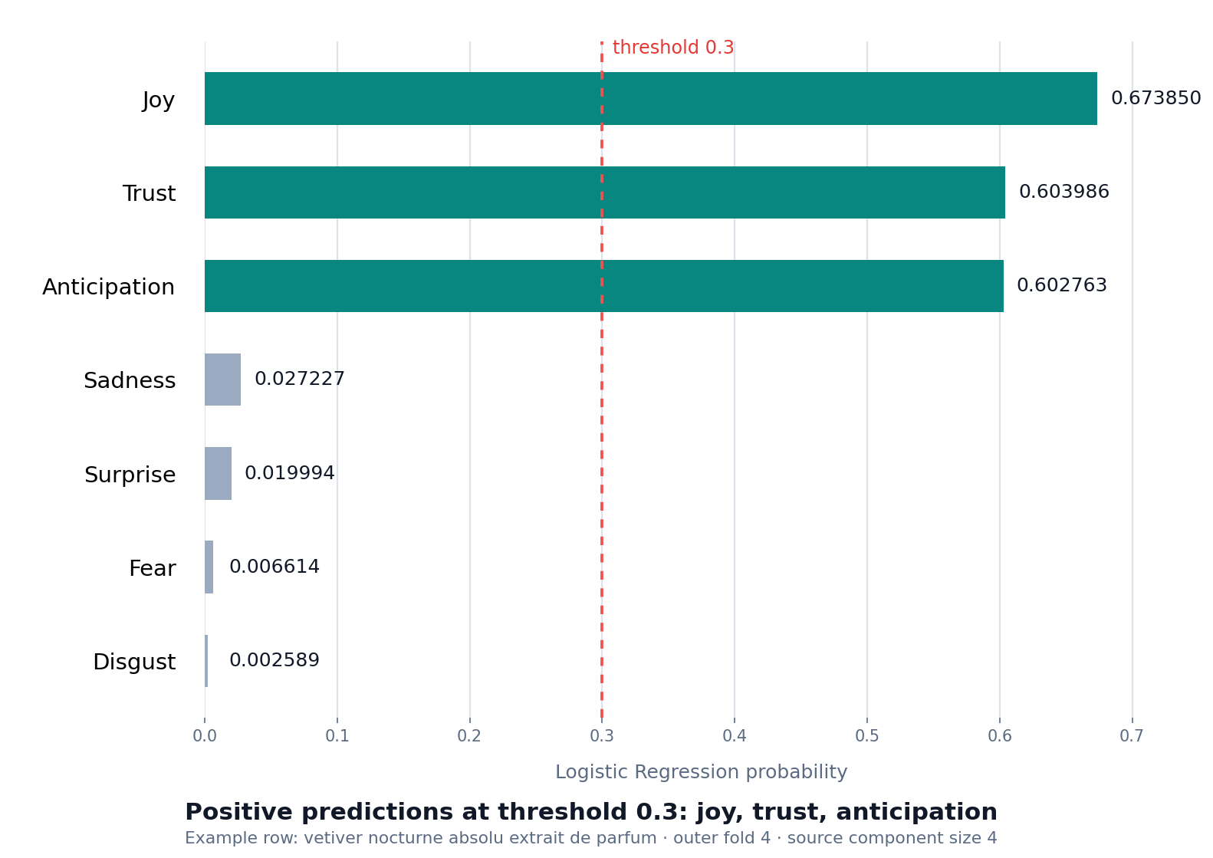
Figure 7: Logistic Regression probabilities for the example perfume.

This example is an explanatory trace, not a standalone performance result. Its three positive predictions happen to match its three positive Gemini reference labels, but evidence for model performance comes from all 784 out-of-fold predictions in Chapter IV.

CHAPTER IV

EXPERIMENTS AND RESULTS

This chapter examines two practical questions: how well five different models can predict the same seven emotion labels assigned by Gemini to YouTube perfume reviews, and whether adding synthetic perfume reviews to the training data changes that performance. The five models are Logistic Regression, XGBoost, Random Forest, BERT, and BiLSTM with Attention.
The models follow two input paths. Logistic Regression, XGBoost, and Random Forest receive 58 numerical features that summarize emotion words, Valence-Arousal-Dominance (VAD), and the outputs of four pretrained transformer models. BERT and BiLSTM with Attention read the review text itself. Each model is evaluated under two training conditions: YouTube-only training and YouTube training supplemented with weighted synthetic reviews. Synthetic reviews are used only during training. Both conditions are evaluated on YouTube perfumes that were not used to train the model in that fold.
The chapter begins with the shared evaluation rules and metrics. It then reports the machine-learning and deep-learning results separately, brings all five models together in one comparison, and examines uncertainty around the observed differences. The final sections test the structured feature groups, show how the decision threshold changes F1, and explain performance for each emotion label.

4.1 PERFORMANCE EVALUATION
All experiments use an evaluation procedure that keeps related reviews in the same data split. This prevents a model from being tested on a perfume review that is identical to, or directly linked to, material used during training. Perfumes sharing the same YouTube video ID or the same normalized transcript are therefore treated as one source group and kept together during training, validation, and testing.

4.1.1 Evaluation Setup
The 784 perfumes are divided into five folds. Each fold is used once for testing, while the other four provide the permitted training data. The model predicts the test perfumes without using their labels during training. After all five folds, every perfume has one out-of-fold prediction. These predictions are combined to calculate one score per metric for that training seed.
The same fold assignments are used for all five models and both training conditions. In the YouTube-only condition, the model learns from the permitted YouTube training perfumes. In the augmented condition, three synthetic reviews are added for each permitted training perfume. Without weighting, these three generated reviews would have three times the base influence of one natural training perfume. To keep their combined base influence equal to that of one natural training perfume, each synthetic review is given a training weight of one-third. Synthetic reviews linked to test perfumes are removed for every model. For BERT and BiLSTM, reviews linked to inner-validation perfumes are also removed. The test data always consist of held-out YouTube perfumes; synthetic reviews are never used as the formal test set.
The full five-fold evaluation is repeated for five training seeds. For each seed, the out-of-fold predictions are pooled to calculate one score per metric. Tables 9, 10, and 12 report the mean and sample standard deviation of these five scores. The standard deviation uses n − 1 = 4 as its denominator. It measures variation between training seeds, rather than between folds. Scores are calculated before averaging across seeds; the probabilities are not combined across seeds. A smaller standard deviation means less variation in the tested runs. A value of 0.0000 can mean identical scores or a difference too small to appear at four decimal places.
Table 8 summarizes the common setup. Because some perfumes share review sources, the 784 perfumes form 359 source groups. The main results count each perfume equally, while an additional check gives each source group equal influence.

Table 8: Experimental and evaluation setup for the five-model comparison
Item | Setting
Natural-language source | 4,881 usable raw YouTube transcript rows; after two exact duplicate rows are removed, BERT and BiLSTM use 4,879 text chunks. Both counts cover the same 784 perfumes.
Evaluation units | 784 YouTube perfumes
Exact-source groups | 359 groups based on shared video IDs or identical normalized transcripts
Largest source group | 334 perfumes
Outer evaluation folds | Five; each perfume is tested once while its fold is held out
Training condition 1 | YouTube-only training
Training condition 2 | YouTube training plus three synthetic reviews for each permitted training perfume
Table 8 Continued: Experimental and evaluation setup for the five-model comparison
Item | Setting
Synthetic-review base weight | One-third per review
Test data | Held-out YouTube perfumes only
Official target labels | Joy, sadness, fear, trust, surprise, anticipation, and disgust
Excluded schema label | Anger: 7 positive YouTube perfumes and 0 positive synthetic reviews
Table 8 Continued: Experimental and evaluation setup for the five-model comparison
Item | Setting
Decision threshold | 0.3
Seed-42 source-group bootstrap | 2,000 repetitions using seed 42
Training seeds | 42, 123, 2026, 7, 99; fixed split seed 42
Main result summary | Mean ± sample SD of five pooled OOF scores

4.1.2 Emotion Labels
Gemini 3.1 Pro assigned eight emotion labels during annotation: joy, sadness, anger, fear, trust, surprise, anticipation, and disgust. These are model-based reference labels. They provide a consistent target for the classifiers, but they should not be treated as human-verified ground truth about how a perfume makes people feel.
Anger is excluded from the official model targets because it does not have enough support for a stable comparison across the two data sources. It appears in 7 YouTube perfumes and in 0 synthetic reviews. The main evaluation therefore uses the remaining seven labels, including fear.
Fear remains part of the official seven-label evaluation even though only 3 YouTube perfumes have a positive fear label. A secondary six-label calculation omits fear when the final metrics are averaged. This check uses the same saved model predictions; the models are not trained again. Its purpose is only to show whether this very rare label changes the overall interpretation.

4.1.3 Evaluation Metrics
Each perfume can have more than one positive emotion label, which makes this a multi-label classification task [43]. The labels also occur at very different frequencies. For these reasons, the results are not summarized by accuracy alone. Three macro-averaged metrics are used, meaning that each emotion is evaluated separately and receives equal weight in the final average [34].
Macro-F1 combines precision and recall [34]. In this thesis, each probability is first converted into a yes/no prediction at the prespecified threshold of 0.3, and the seven emotion-level F1 values are then averaged. Macro average precision (Macro AP) summarizes the precision–recall ranking from the probability scores. It is calculated separately for each emotion and averaged without weighting labels by frequency [46]. In this thesis, macro AP averages seven emotion-level values. This differs from calculating trapezoidal area under a precision–recall curve, so the metric is called Macro AP rather than PR-AUC [46]. Macro AP is the primary ranking metric because precision–recall analysis is especially informative when positive examples are rare [17]. Macro ROC-AUC is reported as a second ranking measure.
The main five-seed results give each perfume equal weight. A supplementary analysis uses the saved seed-42 predictions. It compares equal weighting of the 784 perfumes with equal weighting of the 359 source groups. Perfumes belong to the same group when they share a video or transcript. Equal group weighting limits the influence of large groups. The groups are then resampled to calculate a 95% bootstrap interval for each comparison [44]. An interval that includes zero does not clearly distinguish the two models or training conditions. These intervals are unadjusted for multiple comparisons and are treated as supporting evidence [45].
The two measures of variation answer different questions. Standard deviation across seeds shows how scores change when training is repeated on fixed splits. Source-group bootstrap intervals show uncertainty from resampling the review sources while keeping the seed-42 predictions fixed. The two measures are reported separately; they do not form a combined confidence interval.

4.2 PERFORMANCE OF MACHINE-LEARNING MODELS
Logistic Regression, XGBoost, and Random Forest use a feature-based input: each perfume is described by 58 numerical values. These comprise 10 NRC emotion-lexicon features, 3 VAD features, and 45 features derived from the Hartmann, Savani, GoEmotions, and Cardiff transformer models. The three classifiers use the same feature columns and the same held-out perfumes, which allows their results to be compared directly.

4.2.1 YouTube-Only Training
Across five training seeds, Logistic Regression has the highest mean Macro-F1 among the structured-input models (0.3592 ± 0.0000). Random Forest has the highest mean Macro AP (0.3325 ± 0.0034), while XGBoost has the highest mean Macro ROC-AUC (0.5639 ± 0.0043). The leading model therefore depends on the metric.

4.2.2 YouTube and Synthetic Training
The augmented condition keeps the accepted model settings, folds, and test perfumes unchanged and adds only the permitted weighted synthetic reviews to training. Table 9 places the YouTube-only and augmented rows next to each other so that the direction and size of each change can be read directly.

Table 9: Machine-learning performance on held-out YouTube perfumes: mean ± SD across five training seeds
Model | Training data | Macro-F1 | Macro AP | Macro ROC-AUC
Logistic Regression | YouTube-only | 0.3592  ± 0.0000 | 0.3145  ± 0.0000 | 0.5473  ± 0.0000
Logistic Regression | YouTube + synthetic | 0.3737  ± 0.0000 | 0.3505  ± 0.0000 | 0.5372  ± 0.0000
XGBoost | YouTube-only | 0.3308  ± 0.0033 | 0.3068  ± 0.0021 | 0.5639  ± 0.0043
XGBoost | YouTube + synthetic | 0.3358  ± 0.0016 | 0.3112  ± 0.0019 | 0.5950  ± 0.0055
Random Forest | YouTube-only | 0.3309  ± 0.0004 | 0.3325  ± 0.0034 | 0.5632  ± 0.0036
Random Forest | YouTube + synthetic | 0.3259  ± 0.0025 | 0.3222  ± 0.0068 | 0.5704  ± 0.0061

Augmentation changes the three models differently. Logistic Regression gains 0.0144 in mean Macro-F1 and 0.0360 in Macro AP, while ROC-AUC falls by 0.0100. XGBoost gains 0.0050, 0.0044, and 0.0310 in the same metrics. Random Forest loses 0.0050 in Macro-F1 and 0.0103 in Macro AP but gains 0.0072 in ROC-AUC. These differences are calculated by pairing the two conditions within each seed.

4.3 PERFORMANCE OF DEEP-LEARNING MODELS
BERT and BiLSTM with Attention read the review text directly and learn from the words and their order. They do not receive the 58 numerical features because those features are the input designed for the three feature-based models. This keeps the two model families as distinct comparison approaches.

4.3.1 YouTube-Only Training
Across five seeds, BERT has a mean Macro-F1 of 0.3502 ± 0.0303, Macro AP of 0.3307 ± 0.0172, and ROC-AUC of 0.5438 ± 0.0123. BiLSTM with Attention has a mean Macro-F1 of 0.3529 ± 0.0031, Macro AP of 0.3081 ± 0.0272, and ROC-AUC of 0.5164 ± 0.0379. BERT has higher average ranking scores, while BiLSTM has slightly higher average Macro-F1. BERT’s seed-42 Macro-F1 of 0.4029 is higher than its five-seed mean. This single run therefore overstates its average performance across the tested seeds.

4.3.2 YouTube and Synthetic Training
For the deep-learning models, the augmented condition adds the permitted synthetic review text to training and applies the same base-weight rule used by the experiment design. Testing still uses only the held-out YouTube perfumes. Table 10 reports both training conditions.

Table 10: Deep-learning performance on held-out YouTube perfumes: mean ± SD across five training seeds
Model | Training data | Macro-F1 | Macro AP | Macro ROC-AUC
BERT | YouTube-only | 0.3502  ± 0.0303 | 0.3307  ± 0.0172 | 0.5438  ± 0.0123
BERT | YouTube + synthetic | 0.3348  ± 0.0060 | 0.3143  ± 0.0099 | 0.5270  ± 0.0276
BiLSTM with Attention | YouTube-only | 0.3529  ± 0.0031 | 0.3081  ± 0.0272 | 0.5164  ± 0.0379
BiLSTM with Attention | YouTube + synthetic | 0.3424  ± 0.0065 | 0.2828  ± 0.0059 | 0.4816  ± 0.0199

Weighted synthetic training lowers the average scores of both text models. BERT’s changes are −0.0154 in Macro-F1, −0.0164 in Macro AP, and −0.0168 in ROC-AUC. BiLSTM’s changes are −0.0105 in Macro-F1, −0.0253 in Macro AP, and −0.0348 in ROC-AUC. BERT’s paired Macro-F1 change is −0.0154 ± 0.0336 across seeds. The standard deviation shows that its response to augmentation varies between runs.

4.4 OVERALL MODEL COMPARISON
The previous sections separate the models by input type. This section places all five models in the same view and then checks whether the visible differences remain clear after source balance and uncertainty are considered.

4.4.1 Five-Model Macro-F1 Comparison
Figure 8 compares mean Macro-F1 across the five training seeds. Each pair of bars shows one model under YouTube-only and weighted synthetic-augmented training. Error bars show one sample standard deviation across seeds. Both conditions use the same held-out YouTube perfumes and the same threshold of 0.3.

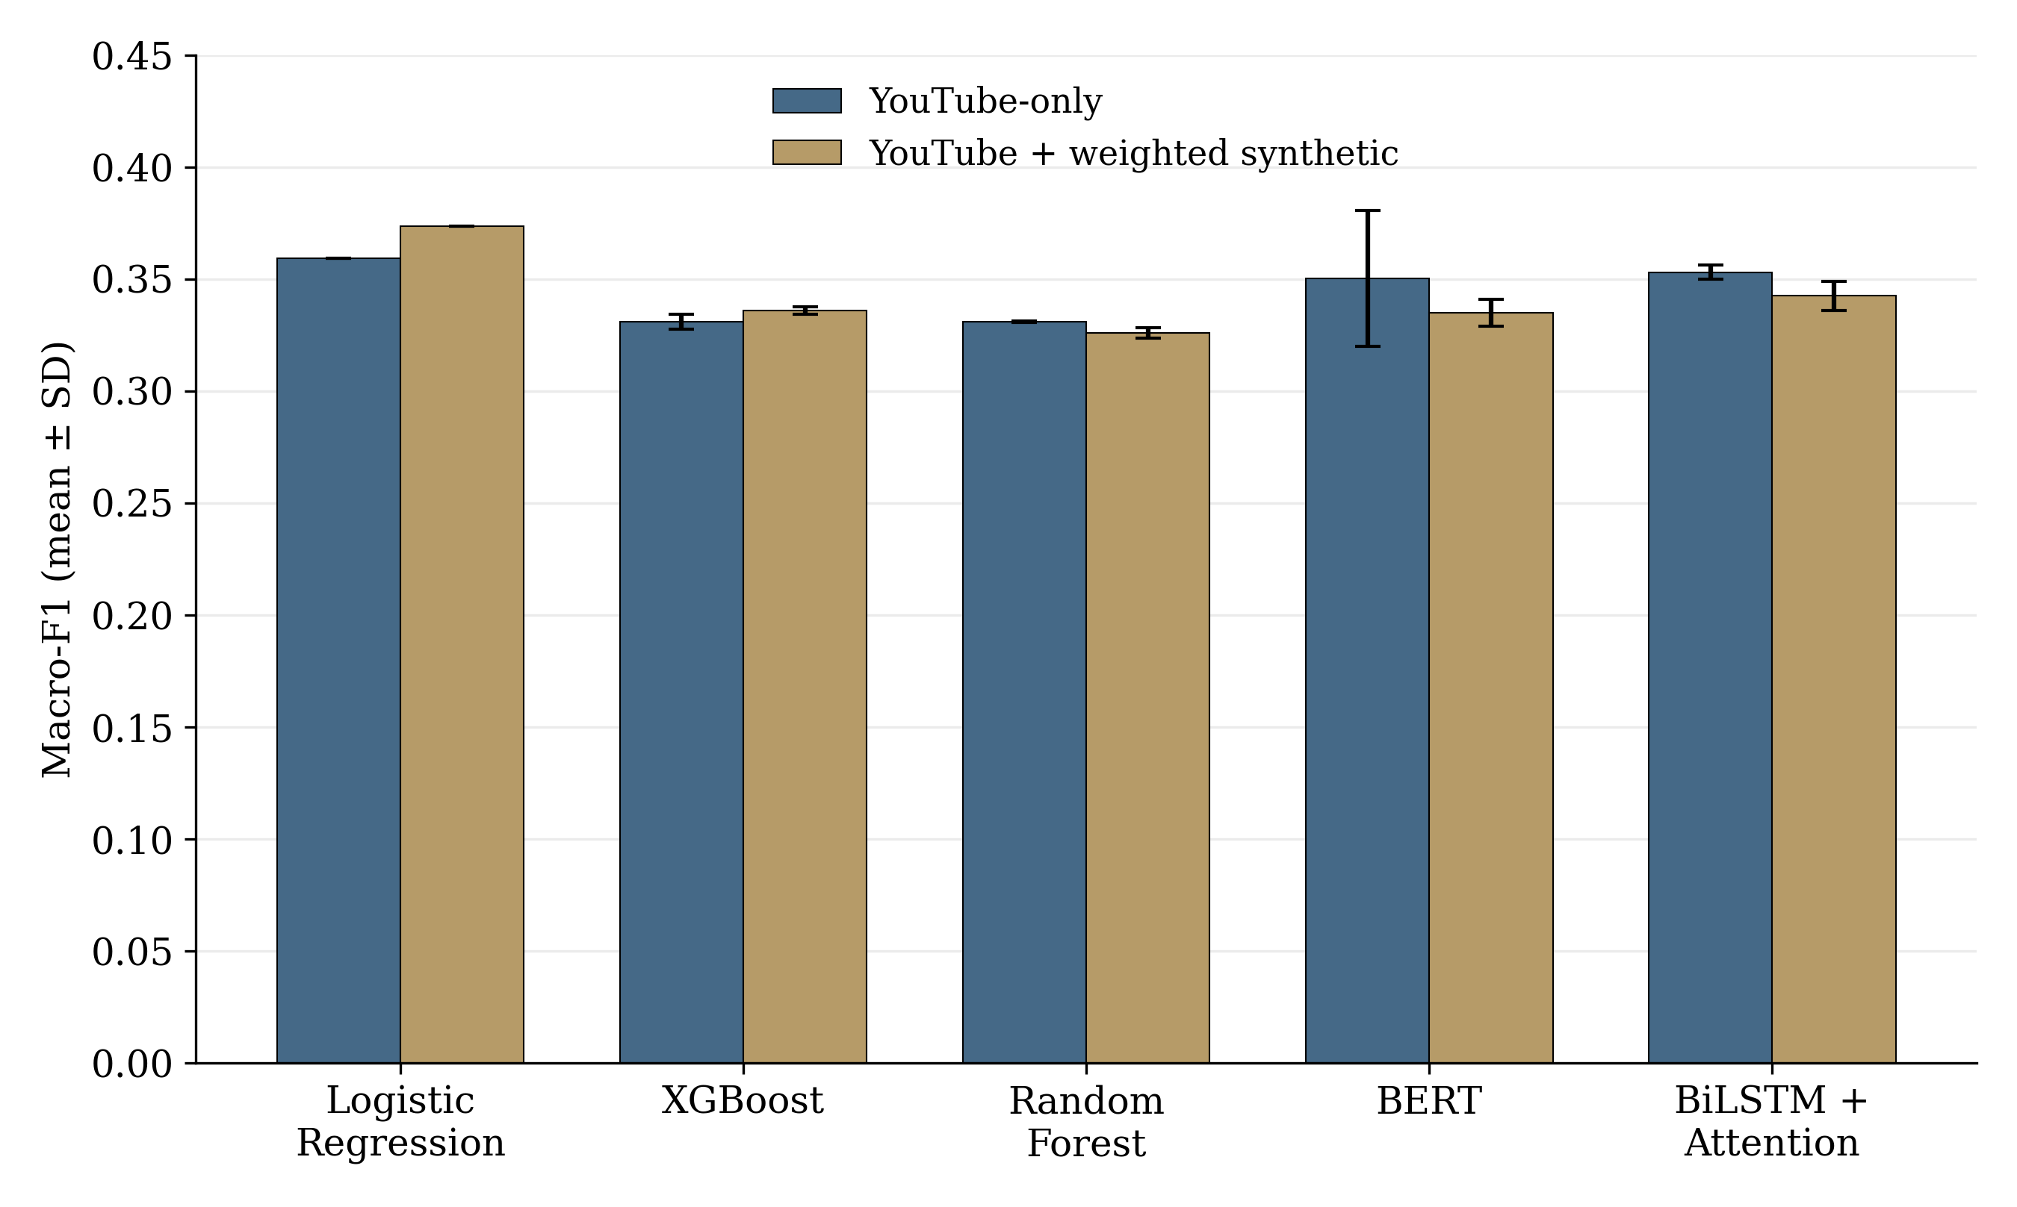
Figure 8: Mean Macro-F1 across five training seeds under YouTube-only and weighted synthetic training. Error bars show one SD; the threshold is 0.3.

Logistic Regression has the highest mean Macro-F1 in both conditions: 0.3592 for YouTube-only training and 0.3737 with augmentation. Mean Macro-F1 increases for Logistic Regression and XGBoost after augmentation. It decreases for Random Forest, BERT, and BiLSTM with Attention. BERT has the largest variation in YouTube-only Macro-F1 across seeds. The error bars show this training variability. Their overlap is not a statistical test of model differences.

4.4.2 Model Comparison with Equal Source-Group Weighting
Some perfumes share review sources, and these groups differ in size. This supplementary seed-42 analysis gives each source group equal influence to check whether the largest group affects the comparison. It uses the original saved predictions and does not replace the five-seed averages in Tables 9 and 10.
With equal source-group weighting, BERT has the highest seed-42 YouTube-only scores: Macro-F1 of 0.4839, Macro AP of 0.4665, and ROC-AUC of 0.5932. However, all 10 pairwise Macro-F1 differences have 95% bootstrap intervals that include zero. Seven of the 20 intervals for Macro AP or ROC-AUC exclude zero, mainly in comparisons with BiLSTM. These results depend on the metric and do not establish one model as best across all measures.

4.4.3 Effect of Synthetic Reviews on Model Performance
The five-seed comparison pairs each augmented run with its YouTube-only run. The mean Macro-F1 change is +0.0144 ± 0.0000 for Logistic Regression and +0.0050 ± 0.0039 for XGBoost. It is −0.0050 ± 0.0023 for Random Forest, −0.0154 ± 0.0336 for BERT, and −0.0105 ± 0.0068 for BiLSTM with Attention. These standard deviations show how the paired changes vary across seeds. They are not confidence intervals. Table 11 reports the separate source-balanced bootstrap analysis of seed-42 predictions.
Table 11 reports source-balanced changes from augmentation using seed-42 predictions. Each change is the augmented score minus the YouTube-only score. Positive values favor augmentation; negative values favor YouTube-only training. The brackets contain 95% bootstrap intervals obtained by resampling the 359 source groups [44]. The intervals are unadjusted: no correction is made for the number of comparisons. They are therefore interpreted as supporting evidence [45]. The official scores include all seven target labels. Fear has only three positive perfumes, so scores are also calculated with fear excluded. This check shows how much the rare fear label affects the comparison. It does not change the official seven-label evaluation.

Table 11: Seed-42 Source-balanced changes from adding weighted synthetic training data, with unadjusted 95% source-group bootstrap intervals
Model | Label scope | Macro-F1 change [95% interval] | Macro AP change [95% interval] | Macro ROC-AUC change [95% interval]
Logistic Regression | Seven labels | +0.0227 [+0.0011, +0.0466]* | +0.1202 [−0.0366, +0.1402] | +0.0081 [−0.0195, +0.0358]
Logistic Regression | Fear omitted | +0.0159 [−0.0037, +0.0338] | −0.0164 [−0.0516, +0.0099] | +0.0049 [−0.0273, +0.0367]
Table 11 Continued: Seed-42 Source-balanced changes from adding weighted synthetic training data, with unadjusted 95% source-group bootstrap intervals
Model | Label scope | Macro-F1 change [95% interval] | Macro AP change [95% interval] | Macro ROC-AUC change [95% interval]
XGBoost | Seven labels | +0.0092 [−0.0205, +0.0393] | +0.0025 [−0.0205, +0.0381] | +0.0286 [−0.0076, +0.0604]
XGBoost | Fear omitted | +0.0107 [−0.0239, +0.0459] | +0.0067 [−0.0155, +0.0432] | +0.0345 [+0.0031, +0.0701]*
Random Forest | Seven labels | −0.0117 [−0.0378, +0.0034] | −0.0244 [−0.1079, +0.0154] | +0.0081 [−0.0390, +0.0564]
Random Forest | Fear omitted | −0.0137 [−0.0441, +0.0040] | −0.0195 [−0.0464, +0.0119] | +0.0098 [−0.0415, +0.0673]
BERT | Seven labels | −0.1417 [−0.1739, +0.0261] | −0.1458 [−0.1726, +0.0722] | −0.0704 [−0.1387, +0.0567]
BERT | Fear omitted | +0.0004 [−0.0388, +0.0392] | −0.0057 [−0.0464, +0.0176] | +0.0114 [−0.0746, +0.0700]
BiLSTM with Attention | Seven labels | −0.0003 [−0.0195, +0.0203] | −0.0044 [−0.0434, +0.0274] | −0.0560 [−0.1563, +0.1595]
BiLSTM with Attention | Fear omitted | +0.0008 [−0.0212, +0.0249] | +0.0073 [−0.0104, +0.0344] | +0.0846 [−0.0454, +0.1766]

Two of the 30 unadjusted seed-42 bootstrap intervals exclude zero: seven-label Macro-F1 for Logistic Regression and fear-excluded ROC-AUC for XGBoost. The other intervals include zero. These intervals describe uncertainty from resampling source groups with one seed’s predictions held fixed. They do not show whether an improvement persists across training seeds. Tables 9 and 10 report the main five-seed results.
The YouTube-only and weighted 784×3 conditions are the main comparisons in this chapter. Earlier synthetic-only, 784×6, SMOTE, hybrid-balancing, and review-count trials answer different questions and remain exploratory. Appendix 2 presents selected XGBoost review-count and balancing results; the other exploratory outputs are retained in the project files.

4.5 ABLATION STUDY AND THRESHOLD SENSITIVITY
This section checks two parts of the experimental design. The ablation study asks whether the three structured-input models depend on one particular feature group. The threshold study asks whether the reported Macro-F1 changes when a different probability cutoff is applied to the same predictions.

4.5.1 Structured-Feature Ablation
The full input contains 58 features: 10 NRC, 3 VAD, and 45 transformer-derived features. The transformer group combines Hartmann, Savani, GoEmotions, and Cardiff outputs. Seven representations are compared: each group alone, each pair of groups, and all groups together. Logistic Regression, XGBoost, and Random Forest are evaluated with each representation using all five training seeds. The folds, other model settings, and threshold remain fixed.
This ablation removes groups of columns from the 58-feature input. BERT and BiLSTM with Attention use transcript text and do not receive these columns. Removing NRC, VAD, or transformer-derived feature columns therefore does not apply to them. Table 10 reports their five-seed results. No additional architecture ablation is included.

Table 12: YouTube-only structured-feature ablations at threshold 0.3: mean ± SD across five training seeds
Model | Feature representation | Features | Macro-F1 | Macro AP | Macro ROC-AUC
Logistic Regression | Full representation | 58 | 0.3592  ± 0.0000 | 0.3145  ± 0.0000 | 0.5473  ± 0.0000
Logistic Regression | NRC only | 10 | 0.3591  ± 0.0000 | 0.3216  ± 0.0000 | 0.5074  ± 0.0000
Logistic Regression | VAD only | 3 | 0.3544  ± 0.0000 | 0.3241  ± 0.0000 | 0.5884  ± 0.0000
Logistic Regression | Transformer-derived only | 45 | 0.3556  ± 0.0000 | 0.3395  ± 0.0000 | 0.5772  ± 0.0000
Logistic Regression | NRC + VAD | 13 | 0.3602  ± 0.0000 | 0.3318  ± 0.0000 | 0.5338  ± 0.0000
Logistic Regression | NRC + Transformer-derived | 55 | 0.3600  ± 0.0000 | 0.3130  ± 0.0000 | 0.5416  ± 0.0000
Logistic Regression | VAD + Transformer-derived | 48 | 0.3544  ± 0.0000 | 0.3486  ± 0.0000 | 0.5838  ± 0.0000
XGBoost | Full representation | 58 | 0.3308  ± 0.0033 | 0.3068  ± 0.0021 | 0.5639  ± 0.0043
XGBoost | NRC only | 10 | 0.3782  ± 0.0027 | 0.3423  ± 0.0131 | 0.5626  ± 0.0013
XGBoost | VAD only | 3 | 0.3276  ± 0.0010 | 0.2797  ± 0.0007 | 0.5319  ± 0.0030
XGBoost | Transformer-derived only | 45 | 0.3256  ± 0.0052 | 0.2986  ± 0.0014 | 0.5503  ± 0.0030
XGBoost | NRC + VAD | 13 | 0.3799  ± 0.0057 | 0.3361  ± 0.0115 | 0.5701  ± 0.0026
XGBoost | NRC + Transformer-derived | 55 | 0.3298  ± 0.0029 | 0.3043  ± 0.0016 | 0.5601  ± 0.0062
XGBoost | VAD + Transformer-derived | 48 | 0.3314  ± 0.0042 | 0.3020  ± 0.0022 | 0.5507  ± 0.0034
Random Forest | Full representation | 58 | 0.3309  ± 0.0004 | 0.3325  ± 0.0034 | 0.5632  ± 0.0036
Random Forest | NRC only | 10 | 0.3212  ± 0.0006 | 0.2936  ± 0.0011 | 0.5011  ± 0.0062
Random Forest | VAD only | 3 | 0.3237  ± 0.0004 | 0.2801  ± 0.0011 | 0.5176  ± 0.0036
Random Forest | Transformer-derived only | 45 | 0.3259  ± 0.0029 | 0.3144  ± 0.0021 | 0.5269  ± 0.0115
Random Forest | NRC + VAD | 13 | 0.3226  ± 0.0002 | 0.3051  ± 0.0029 | 0.5403  ± 0.0025
Random Forest | NRC + Transformer-derived | 55 | 0.3305  ± 0.0002 | 0.3293  ± 0.0033 | 0.5581  ± 0.0044
Random Forest | VAD + Transformer-derived | 48 | 0.3283  ± 0.0033 | 0.3148  ± 0.0029 | 0.5328  ± 0.0087

The five-seed averages show different patterns across models. Logistic Regression’s mean Macro-F1 varies little across the seven representations, while its Macro AP and ROC-AUC vary more. XGBoost has its highest mean Macro-F1 with NRC + VAD (0.3799 ± 0.0057) and its highest mean Macro AP with NRC alone (0.3423 ± 0.0131). Random Forest has its highest mean value for all three metrics with the full representation. These comparisons do not identify a feature set that is best for every model and metric.
The supplementary seed-42 bootstrap analysis covers 108 comparisons across models, label scopes, and metrics. All 36 Logistic Regression intervals include zero. For XGBoost, 2 of 36 intervals exclude zero; both favor the full feature set over VAD alone for Macro AP. For Random Forest, 8 of 36 intervals exclude zero, mostly in favor of the full set for Macro AP. An interval that excludes zero has the same direction of difference throughout its range. The full set performs better in some comparisons, but no representation is best across all models and metrics. These results concern predictive performance and do not establish causal feature importance.

4.5.2 Threshold Sensitivity
The official decision threshold is 0.3. The saved seed-42 YouTube-only probabilities are also evaluated at 0.2, 0.5, and 0.7 to check how the threshold affects Macro-F1. This requires no retraining. Only the cutoff used to convert probabilities into yes/no labels changes. Macro AP uses the probability scores directly [46], so it remains unchanged. ROC-AUC also remains unchanged because the probability scores are the same.

Table 13: Seed-42 Macro-F1 from the same YouTube-only out-of-fold probabilities at four fixed thresholds
Model | 0.2 | 0.3 (official) | 0.5 | 0.7
Logistic Regression | 0.3590 | 0.3592 | 0.2985 | 0.1690
XGBoost | 0.3409 | 0.3260 | 0.2950 | 0.2248
Random Forest | 0.3526 | 0.3306 | 0.2952 | 0.1669
BERT | 0.3926 | 0.4029 | 0.2899 | 0.0000
BiLSTM with Attention | 0.3515 | 0.3486 | 0.1943 | 0.0000

Logistic Regression and BERT have their highest tested Macro-F1 at the official threshold of 0.3. XGBoost, Random Forest, and BiLSTM with Attention are highest at 0.2. At 0.7, BERT makes no positive predictions, while BiLSTM makes one false-positive prediction; both therefore have a Macro-F1 of zero. This does not mean that their probability outputs contain no information; it means that the cutoff is too high for their probability scale. The official threshold remains 0.3 because it was specified before this sensitivity check, rather than selected after examining the test results.

4.6 LABEL-LEVEL EVALUATION AND MODEL ANALYSIS
Overall averages can hide differences between common and rare emotions. This section uses the original seed-42 predictions to examine F1 for each label and the number of positive predictions made by each model.

4.6.1 Performance for Each Emotion
The seven labels are highly imbalanced. Joy is positive for 622 perfumes, trust for 476, and anticipation for 366. Surprise has 44 positives, disgust 19, sadness 11, and fear only 3. Table 14 reports seed-42 YouTube-only F1 for each emotion at threshold 0.3.

Table 14: Seed-42 Per-label F1 for the five YouTube-only models at threshold 0.3
Emotion | Positive YouTube perfumes | Logistic Regression | XGBoost | Random Forest | BERT | BiLSTM with Attention
Joy | 622 | 0.8614 | 0.8774 | 0.8848 | 0.8848 | 0.8848
Sadness | 11 | 0.0435 | 0.0000 | 0.0000 | 0.0000 | 0.0261
Fear | 3 | 0.0833 | 0.0000 | 0.0000 | 0.5000 | 0.0108
Trust | 476 | 0.7376 | 0.7179 | 0.7556 | 0.7556 | 0.7556
Surprise | 44 | 0.1274 | 0.1034 | 0.0444 | 0.0435 | 0.1068
Anticipation | 366 | 0.6380 | 0.5831 | 0.6294 | 0.6365 | 0.6365
Disgust | 19 | 0.0235 | 0.0000 | 0.0000 | 0.0000 | 0.0197

All five models perform much better on the common labels than on the rare labels. Joy F1 ranges from 0.8614 to 0.8848, trust from 0.7179 to 0.7556, and anticipation from 0.5831 to 0.6380. Results for sadness, fear, and disgust are much lower and less stable.
Fear requires particular care. BERT's fear F1 of 0.5000 comes from one correct positive prediction among only three positive perfumes. One prediction can therefore change the value sharply, so this number is not strong evidence that BERT has learned fear reliably. The secondary fear-omitted calculation in Table 11 checks whether this rare label changes the broader augmentation conclusion.

4.6.2 Model Prediction Behavior
Models with similar average scores can make different numbers of positive predictions. Table 15 compares actual positive counts with each model’s seed-42 YouTube-only predictions. A perfume can be positive for several emotions because the task is multi-label.

Table 15: Seed-42 Actual and predicted positive counts for the five YouTube-only models at threshold 0.3
Emotion | Actual positives | Logistic Regression | XGBoost | Random Forest | BERT | BiLSTM with Attention
Joy | 622 | 706 | 757 | 784 | 784 | 784
Sadness | 11 | 127 | 1 | 0 | 0 | 526
Fear | 3 | 21 | 4 | 1 | 1 | 182
Trust | 476 | 709 | 683 | 784 | 784 | 784
Surprise | 44 | 270 | 14 | 1 | 2 | 780
Anticipation | 366 | 681 | 567 | 743 | 784 | 784
Disgust | 19 | 151 | 2 | 0 | 2 | 489

XGBoost is the most selective of the five models for the rare labels: it predicts sadness once, surprise 14 times, and disgust twice. BiLSTM with Attention makes a much broader set of positive predictions, including surprise for 780 perfumes and sadness for 526. BERT predicts joy, trust, and anticipation for all 784 perfumes but is highly selective for the rare labels. Random Forest follows a similar pattern for the common labels and predicts almost none of the rare ones. Class-weighted Logistic Regression lies between these patterns but still predicts many more rare positives than are present, such as 127 sadness predictions for 11 actual positives and 270 surprise predictions for 44 actual positives.
These counts explain why the models change position across the metrics. A model that predicts many positives may find more true examples but also create more false alarms. A selective model may avoid false alarms while missing positive cases. Aggregate true-positive, false-positive, true-negative, and false-negative totals are retained in Appendix 2, Table 19.
Across five seeds, Logistic Regression has the highest mean YouTube-only Macro-F1, Random Forest the highest Macro AP, and XGBoost the highest ROC-AUC. BERT’s strong original result varies across repeated runs. Augmentation improves some scores for the structured-input models but lowers the averages of both text models. The feature-ablation results depend on the model. The seed-42 diagnostics also show the difficulty of evaluating rare emotions. Chapter V discusses these findings and their limitations.

CHAPTER V

DISCUSSION

This chapter interprets the experimental results in relation to the three research questions. It discusses what the models learned, how synthetic training affected them, and which limitations should be considered when reading the findings.

5.1 CENTRAL INTERPRETATION
Repeating the experiments with five training seeds reduced dependence on a single training run. BERT’s strong seed-42 results did not persist as the highest five-seed averages, while Logistic Regression remained stable. Under YouTube-only training, Logistic Regression has the highest mean Macro-F1, Random Forest the highest Macro AP, and XGBoost the highest ROC-AUC (Tables 9 and 10). The additional seeds did not improve or worsen the models themselves. They provided a performance estimate based on repeated training and showed how much scores varied across seeds.
Performance also depends on label imbalance and the decision threshold. In the seed-42 results, BERT predicts common labels broadly, while XGBoost is more selective. Class-weighted Logistic Regression produces many false positives for rare labels (Table 15). Table 13 shows how Macro-F1 changes with the threshold. Macro-F1 is therefore considered alongside ranking metrics, per-label scores, and prediction counts. Label imbalance is a known difficulty for deep-learning emotion models [15]. Precision–recall analysis is also useful when positive examples are rare [17].
Synthetic augmentation does not improve every model. Logistic Regression and XGBoost gain on some average metrics, Random Forest has mixed changes, and both BERT and BiLSTM decline on all three averages. The bootstrap analysis uses the original seed-42 predictions to estimate uncertainty by resampling source groups. It provides limited supporting evidence of improvement. Under the tested conditions, the effect of synthetic augmentation depends on the model and evaluation metric.

5.2 RQ1: STRUCTURED REPRESENTATION OF PERFUME-REVIEW EMOTION
The results for RQ1 show that perfume-review transcripts can be converted into a perfume-level feature matrix containing lexical, dimensional, and contextual emotion information. NRC supplies explicit word–emotion associations [5], [6], while VAD represents pleasantness, activation, and control [7], [8]. The GoEmotions dataset provides the fine-grained emotion label space used by the GoEmotions-based feature family [9]. The Hartmann, Savani, GoEmotions, and Cardiff checkpoints provide emotion scores [10]–[13]. These feature families are combined in the 58-column structured input described in Section 3.5.
The structured models all have mean YouTube-only ROC-AUC above 0.54 with the full representation (Table 12). Across five seeds, Logistic Regression’s mean Macro-F1 changes little among the seven feature combinations, while its Macro AP and ROC-AUC vary more. XGBoost has its highest mean Macro-F1 with NRC + VAD, while Random Forest has its highest mean score on all three metrics with the full representation. The value of a feature group therefore depends on the classifier and evaluation metric.
The supplementary seed-42 feature comparisons differ by model (Section 4.5.1). None of the 36 Logistic Regression intervals exclude zero. Two of the 36 XGBoost intervals and eight of the 36 Random Forest intervals do. These 108 intervals are unadjusted and use fixed out-of-fold predictions. They do not establish one best representation or causal feature importance. NRC and VAD features have explicit lexical or dimensional meanings. Transformer features are model-output probabilities, which are harder to trace to individual words.

5.3 RQ2: PERFORMANCE OF MACHINE LEARNING AND DEEP LEARNING MODELS
Under YouTube-only training, Logistic Regression has the highest mean Macro-F1 at 0.3592 ± 0.0000. Random Forest has the highest mean Macro AP at 0.3325 ± 0.0034, and XGBoost has the highest mean ROC-AUC at 0.5639 ± 0.0043. BERT’s mean Macro AP is close to Random Forest’s at 0.3307 ± 0.0172, but varies more across seeds. The results favor different models for different metrics.
BERT’s YouTube-only Macro-F1 is 0.4029 in the original seed-42 run and 0.3502 ± 0.0303 across five seeds. BiLSTM averages 0.3529 ± 0.0031 on the same metric. The seed-42 source-balanced comparisons in Section 4.4.2 do not test differences between these five-seed means. The standard deviations describe variation across the tested seeds. They do not measure variation across new datasets.
The seed-42 prediction counts illustrate different model behaviors (Table 15). XGBoost is the most selective, whereas BiLSTM with Attention predicts the broadest set of labels. BERT predicts the common labels broadly, and weighted Logistic Regression produces many false positives for rare labels. Random Forest shows a more selective tree-ensemble pattern. These differences help explain why metric rankings vary.

5.4 THRESHOLDS, RARE LABELS, AND APPARENT PERFORMANCE
In the seed-42 analysis, changing the threshold changes which predictions are positive (Table 13). Several models have higher Macro-F1 at 0.2, while Logistic Regression and BERT are highest at 0.3. At 0.7, BERT predicts no positives and BiLSTM predicts one false positive. Both therefore have a Macro-F1 of zero. ROC-AUC and Macro AP use the unchanged probability scores, so varying the cutoff does not change them (Section 4.1.3).
Rare-label scores are sensitive to individual predictions. Fear has three positive examples, sadness 11, and disgust 19 (Table 14). BERT’s seed-42 fear F1 of 0.5 comes from one correct positive prediction. It is therefore interpreted cautiously. The more common labels provide a larger basis for evaluation.

5.5 RQ3: SYNTHETIC DATA
The five-seed results show model-dependent effects of weighted augmentation. Logistic Regression improves in mean Macro-F1 and Macro AP but declines in ROC-AUC. XGBoost improves on all three averages, while Random Forest has mixed changes. Both text models decline on all three averages. For BERT, the paired Macro-F1 change of −0.0154 ± 0.0336 also shows substantial variation in the response across seeds.
Table 11 reports 30 supplementary seed-42 intervals with equal source-group weighting. Only two exclude zero: seven-label Macro-F1 for Logistic Regression (+0.0227 [0.0011, 0.0466]) and fear-excluded Macro ROC-AUC for XGBoost (+0.0345 [0.0031, 0.0701]). The other 28 intervals include zero. These comparisons have no multiplicity correction and do not show a consistent augmentation benefit across models, metrics, and label scopes.
The base-weight design described in Section 4.1.1 gives the three synthetic reviews total nominal mass 1 per training perfume, matching the natural perfume's base mass. The experiment still combines different observation units and model-specific weighting mechanisms. The findings therefore apply to the tested protocol; the synthetic-only, 784×6, balancing, and review-count variants remain exploratory. Section 2.1 of Appendix 2 presents selected XGBoost review-count and balancing results.

5.6 VALIDITY AND LIMITATIONS
This section explains what the results can and cannot establish. The limitations are grouped by the meaning of the labels and features, the experimental design, the strength of the conclusions, their wider applicability, and reproducibility.

5.6.1 Construct Validity
The reference labels represent a Gemini 3.1 Pro browser annotation policy rather than human-verified emotion. Odor naming varies across languages [1], and odors are closely linked with mood and emotion [3]. A label inferred from no more than two short text excerpts therefore cannot directly measure a person's sensory experience or be treated as human-verified emotion. The Hartmann, Savani, GoEmotions, and Cardiff checkpoints were developed from general emotion or social-text datasets rather than perfume-review data [9]–[13], [27]. Their outputs are therefore treated as model-derived contextual inputs, not definitive emotion judgments. Appendix 2 provides the detailed source audit. A human-adjudicated sample would help establish how closely the pipeline reflects human perception.

5.6.2 Internal Validity
Exact-source grouping keeps shared videos and identical transcripts within one fold, and synthetic reviews linked to held-out perfumes are excluded from training. These controls reduce direct source overlap. Channel-level grouping did not produce sufficiently balanced folds, so broader reviewer or channel dependence may remain. The real and synthetic examples also differ: YouTube inputs are perfume-level structured aggregates or sets of natural transcript chunks, whereas synthetic inputs are individual generated reviews. The base weights give one real perfume and its three synthetic reviews the same nominal total weight, but model-specific class weighting, tree behavior, and loss construction can still produce different final influence. The feature extractors and browser labeler also use different text windows.
One source group contains 334 perfumes, creating one large test fold and four smaller folds. The component-equal estimates and source-group uncertainty intervals reported in Section 4.4.2 account for this imbalance in the model comparison. Independently collected data would provide the strongest confirmation.

5.6.3 Conclusion Validity
Rare emotions have few positive examples, so individual predictions can change their scores substantially. The five training seeds measure variation on fixed splits. They do not measure variation across different splits, datasets, or annotation policies. The source-group bootstrap intervals in Sections 4.4 and 4.5 use seed-42 predictions and are unadjusted. They describe a separate source of uncertainty from the standard deviations across seeds. Hyperparameters were not re-optimized for feature subsets. In Random Forest, the square-root feature-sampling rule changes the number of candidate features when the input dimension changes. The decision threshold remains 0.3.

5.6.4 External Validity
The fixed benchmark contains 784 perfume-level examples derived from English-language YouTube review transcripts. Keeping this dataset fixed supports reproducibility, but the results may not transfer to written retail reviews, other platforms, other languages, short social-media posts, or direct sensory experiments. Synthetic reviews are generated under a controlled process and cannot substitute for independently collected natural text.

5.6.5 Reproducibility
The reproducibility files record input hashes, split assignments, predictions, model settings, and checks on reused seed-42 results. The five-seed results are stored in outputs/thesis_three_seed_v1. This directory keeps its name from the initial three-seed stage. The completed inventory contains 50 main jobs and 145 structured-feature jobs. Table 12 presents seven shared feature combinations for three models across five seeds, covering 105 jobs; the remaining 40 jobs cover eight additional Logistic Regression variants across five seeds. The revised tables and figure are documented in outputs/thesis_five_seed_revision_20261012. The earlier consolidation package supplies the seed-42 diagnostics. Appendix 1 gives the implementation and checkpoint details.

CHAPTER VI

CONCLUSION AND FUTURE WORK

This chapter brings together the main findings of the thesis, answers the research questions, and identifies directions for future work.

6.1 CONCLUSION
This thesis developed a reproducible pipeline for multi-label emotion analysis of perfume-review language. As detailed in Chapter III, it converts YouTube transcripts into perfume-level data, combines affective lexicons, VAD dimensions, and pretrained emotion-model outputs, and uses structured browser annotations as reference labels. Within this framework, five models were evaluated under the same source-isolated protocol: Logistic Regression, XGBoost, Random Forest, BERT, and BiLSTM with Attention.
To assess performance, the study uses the source-grouped benchmark of 784 perfumes described in Section 4.1. The main comparisons and structured-feature ablations use five training seeds with fixed source-grouped splits. Reporting both means and standard deviations shows average performance alongside variation across training seeds.
Across these repeated experiments, no model has the highest average score on every metric. With YouTube-only training, Logistic Regression leads mean Macro-F1, Random Forest leads Macro AP, and XGBoost leads ROC-AUC. When synthetic reviews are added, the structured-input models show mixed changes, while both text models have lower average scores. The effect of augmentation therefore depends on the model and metric under the tested conditions. Further evaluation with independent, human-reviewed data is needed to assess whether these patterns hold more widely.

6.2 ANSWERS TO THE RESEARCH QUESTIONS

6.2.1 RQ1: Representation
The study represents perfume-review transcripts through a perfume-level matrix of NRC emotion counts, VAD dimensions, and scores from Hartmann, Savani, GoEmotions, and Cardiff (Section 3.5). To examine the contribution of these inputs, seven feature combinations were evaluated with five training seeds (Section 4.5.1). Logistic Regression’s mean Macro-F1 changes little across combinations, whereas XGBoost performs better with reduced combinations on some metrics. Random Forest, in turn, most consistently favors the full input. The five-seed results show that the highest-scoring feature combination depends on the model and metric. The supplementary seed-42 bootstrap analysis checks uncertainty around the feature comparisons. Interpretation also differs across features: 13 columns have explicit NRC or VAD meanings, while 45 contain model-output probabilities. Individual features therefore differ in how directly they can be interpreted.

6.2.2 RQ2: Model Performance and Comparison
The model comparison likewise gives different leaders for each metric. In the five-seed YouTube-only results, Logistic Regression leads mean Macro-F1, Random Forest leads Macro AP, and XGBoost leads ROC-AUC. Although BERT leads Macro-F1 and Macro AP in the original run, this lead does not hold in the five-seed averages (Tables 9 and 10).
This difference shows why repeated training matters: scores vary across seeds, especially for BERT. The seed-42 source-balanced analysis provides a separate check on the influence of shared review sources. However, it does not establish one model as best across metrics or training seeds.

6.2.3 RQ3: Synthetic Data
The effect of weighted synthetic augmentation is also model-dependent. Logistic Regression improves in mean Macro-F1 and Macro AP, while XGBoost improves on all three average metrics. Random Forest shows mixed changes. In contrast, BERT and BiLSTM with Attention decline on all three averages. These findings therefore describe the tested weighting scheme, generated reviews, and fixed evaluation splits, rather than a general effect of synthetic training data.

6.3 FUTURE WORK
These findings point first to the need for a human-reviewed validation sample to validate the reference labels. Reviewers should confirm that each excerpt discusses the target perfume and preserves enough emotional context. Independent human annotations would then show how closely the model-based labels match human judgments.
Beyond label validation, independent data from new channels and platforms are needed to assess generalization. Preserving reviewer, video, transcript, and perfume identities would allow the same source-isolation rules to be applied to these data.
The limited support for rare emotions also needs attention. More positive examples, a revised label structure, or both could improve support for fear, sadness, and disgust. Alongside this work, future experiments should select decision thresholds and calibration procedures within their training and validation data. An independent dataset should remain reserved for final evaluation.
The differences between feature combinations also warrant further study on independent data. Candidate architectures should be tuned using training data only. This would allow future work to examine smaller structured representations and the explicit fusion of NRC/VAD features with BERT or BiLSTM text representations. The aim would be to improve performance without reducing rare-label coverage.
Finally, the weighted 784×3 comparison should be repeated on independent natural data with aligned observation units. For example, synthetic reviews could be aggregated to perfume level, or real transcripts could be labeled at review level. Comparing prompts and generators would also help assess the diversity and realism of the generated text.

REFERENCES

[1] MAJID A. and BURENHULT N. (2014), “Odors are expressible in language, as long as you speak the right language”, Cognition, Vol. 130, No. 2, pp. 266–270, DOI: 10.1016/j.cognition.2013.11.004.
[2] NIKITINA L. and FURUOKA F. (2023), “Words of scents: A linguistic analysis of online perfume reviews”, Linguistics Vanguard, Vol. 9, No. 1, pp. 205–214, DOI: 10.1515/lingvan-2022-0135.
[3] KONTARIS I., EAST B. S. and WILSON D. A. (2020), “Behavioral and Neurobiological Convergence of Odor, Mood and Emotion: A Review”, Frontiers in Behavioral Neuroscience, Vol. 14, Article 35, DOI: 10.3389/fnbeh.2020.00035.
[4] NANDWANI P. and VERMA R. (2021), “A review on sentiment analysis and emotion detection from text”, Social Network Analysis and Mining, Vol. 11, Article 81, DOI: 10.1007/s13278-021-00776-6.
[5] MOHAMMAD S. M. and TURNEY P. D. (2013), “Crowdsourcing a Word–Emotion Association Lexicon”, Computational Intelligence, Vol. 29, No. 3, pp. 436–465, DOI: 10.1111/j.1467-8640.2012.00460.x.
[6] MOHAMMAD S. M. and TURNEY P. D. (2010), “Emotions Evoked by Common Words and Phrases: Using Mechanical Turk to Create an Emotion Lexicon”, In Proceedings of the NAACL HLT 2010 Workshop on Computational Approaches to Analysis and Generation of Emotion in Text, Los Angeles, CA, USA, pp. 26–34.
[7] WARRINER A. B., KUPERMAN V. and BRYSBAERT M. (2013), “Norms of Valence, Arousal, and Dominance for 13,915 English Lemmas”, Behavior Research Methods, Vol. 45, pp. 1191–1207.
[8] MOHAMMAD S. M. (2018), “Obtaining Reliable Human Ratings of Valence, Arousal, and Dominance for 20,000 English Words”, In Proceedings of the 56th Annual Meeting of the Association for Computational Linguistics, Melbourne, Australia, pp. 174–184.
[9] DEMSZKY D., MOVSHOVITZ-ATTIAS D., KO J., COWEN A., NEMADE G. and RAVI S. (2020), “GoEmotions: A Dataset of Fine-Grained Emotions”, arXiv preprint arXiv:2005.00547.
[10] HARTMANN J. (2022), “Emotion English DistilRoBERTa-base”, Hugging Face Model Card, https://huggingface.co/j-hartmann/emotion-english-distilroberta-base, DoA. 24.08.2026.
[11] SAVANI B. (n.d.), “distilbert-base-uncased-emotion”, Hugging Face Model Card, https://huggingface.co/bhadresh-savani/distilbert-base-uncased-emotion, DoA. 24.08.2026.
[12] CARDIFF NLP (n.d.), “twitter-roberta-base-emotion”, Hugging Face Model Card, https://huggingface.co/cardiffnlp/twitter-roberta-base-emotion, DoA. 24.08.2026.
[13] MONOLOGG (n.d.), “GoEmotions-pytorch: PyTorch Implementation of GoEmotions”, GitHub Repository, https://github.com/monologg/GoEmotions-pytorch, DoA. 26.08.2026.
[14] MOHAMMAD S. M. and KIRITCHENKO S. (2018), “Understanding Emotions: A Dataset of Tweets to Study Interactions between Affect Categories”, In Proceedings of the 11th International Conference on Language Resources and Evaluation (LREC 2018), Miyazaki, Japan, pp. 198–209, https://aclanthology.org/L18-1030/.
[15] YE SHIREN, DING LI and ALI MD RINKU (2023), “Design and Optimization of Loss Functions in Fine-grained Sentiment and Emotion Analysis”, In 2023 5th International Conference on Natural Language Processing (ICNLP), pp. 171–176, DOI: 10.1109/ICNLP58431.2023.00037.
[16] CHAWLA N. V., BOWYER K. W., HALL L. O. and KEGELMEYER W. P. (2002), “SMOTE: Synthetic Minority Over-sampling Technique”, Journal of Artificial Intelligence Research, Vol. 16, pp. 321–357, DOI: 10.1613/jair.953.
[17] SAITO T. and REHMSMEIER M. (2015), “The Precision-Recall Plot Is More Informative than the ROC Plot When Evaluating Binary Classifiers on Imbalanced Datasets”, PLOS ONE, Vol. 10, No. 3, Article e0118432, DOI: 10.1371/journal.pone.0118432.
[18] ZHAO S., HONG X., YANG J., ZHAO Y. and DING G. (2023), “Toward Label-Efficient Emotion and Sentiment Analysis”, Proceedings of the IEEE, Vol. 111, No. 10, pp. 1159–1197, DOI: 10.1109/JPROC.2023.3309299.
[19] GOOGLE DEEPMIND (2026), “Gemini 3.1 Pro Model Card”, 19 February, https://deepmind.google/models/model-cards/gemini-3-1-pro/, DoA. 26.08.2026.
[20] NIU M., EL-TAWIL Y., ROMANA A. and MOWER PROVOST E. (2024), “Rethinking Emotion Annotations in the Era of Large Language Models”, arXiv preprint arXiv:2412.07906.
[21] NIU M., JAISWAL M. and MOWER PROVOST E. (2024), “From Text to Emotion: Unveiling the Emotion Annotation Capabilities of LLMs”, arXiv preprint arXiv:2408.17026.
[22] RUDER D., UUSBERG A. and SIRTS K. (2025), “Assessing the Reliability and Validity of GPT-4 in Annotating Emotion Appraisal Ratings”, arXiv preprint arXiv:2503.16883.
[23] LIU Z., YANG K., XIE Q., ZHANG T. and ANANIADOU S. (2024), “EmoLLMs: A Series of Emotional Large Language Models and Annotation Tools for Comprehensive Affective Analysis”, In Proceedings of the 30th ACM SIGKDD Conference on Knowledge Discovery and Data Mining, Barcelona, Spain, pp. 5487–5496, DOI: 10.1145/3637528.3671552.
[24] CIOBOTARU A., CONSTANTINESCU M. V., DINU L. P. and DUMITRESCU S. D. (2022), “RED v2: Enhancing RED Dataset for Multi-Label Emotion Detection”, In Proceedings of the 13th Conference on Language Resources and Evaluation (LREC 2022), Marseille, France, pp. 1392–1399.
[25] DEVLIN J., CHANG M.-W., LEE K. and TOUTANOVA K. (2019), “BERT: Pre-training of Deep Bidirectional Transformers for Language Understanding”, In Proceedings of the 2019 Conference of the North American Chapter of the Association for Computational Linguistics: Human Language Technologies, Vol. 1, Minneapolis, MN, USA, pp. 4171–4186, DOI: 10.18653/v1/N19-1423.
[26] WANG M.-J. and ZHANG X. (2024), “Discrete Emotions Detection on Social Media: A Systematic Review and Comparative Analysis”, In 2024 IEEE 4th International Conference on Information Technology, Big Data and Artificial Intelligence (ICIBA), pp. 588–597, DOI: 10.1109/ICIBA62489.2024.10867988.
[27] BARBIERI F., CAMACHO-COLLADOS J., ESPINOSA-ANKE L. and NEVES L. (2020), “TweetEval: Unified Benchmark and Comparative Evaluation for Tweet Classification”, In Findings of the Association for Computational Linguistics: EMNLP 2020, Online, pp. 1644–1650, DOI: 10.18653/v1/2020.findings-emnlp.148.
[28] HASTIE T., TIBSHIRANI R. and FRIEDMAN J. (2009), The Elements of Statistical Learning: Data Mining, Inference, and Prediction, 2nd Edition, Springer, New York, DOI: 10.1007/978-0-387-84858-7.
[29] CHEN T. and GUESTRIN C. (2016), “XGBoost: A Scalable Tree Boosting System”, In Proceedings of the 22nd ACM SIGKDD International Conference on Knowledge Discovery and Data Mining, San Francisco, CA, USA, pp. 785–794, DOI: 10.1145/2939672.2939785.
[30] BREIMAN L. (2001), “Random Forests”, Machine Learning, Vol. 45, pp. 5–32, DOI: 10.1023/A:1010933404324.
[31] HOCHREITER S. and SCHMIDHUBER J. (1997), “Long Short-Term Memory”, Neural Computation, Vol. 9, No. 8, pp. 1735–1780, DOI: 10.1162/neco.1997.9.8.1735.
[32] SCHUSTER M. and PALIWAL K. K. (1997), “Bidirectional Recurrent Neural Networks”, IEEE Transactions on Signal Processing, Vol. 45, No. 11, pp. 2673–2681, DOI: 10.1109/78.650093.
[33] BAHDANAU D., CHO K. and BENGIO Y. (2015), “Neural Machine Translation by Jointly Learning to Align and Translate”, In Proceedings of the 3rd International Conference on Learning Representations, San Diego, CA, USA, arXiv:1409.0473.
[34] SOKOLOVA M. and LAPALME G. (2009), “A Systematic Analysis of Performance Measures for Classification Tasks”, Information Processing & Management, Vol. 45, No. 4, pp. 427–437, DOI: 10.1016/j.ipm.2009.03.002.
[35] ZHANG L. (2010), “Metaphor Interpretation and Context-Based Affect Detection”, In COLING 2010: Poster Volume, Beijing, China, pp. 1480–1488.
[36] ZHANG L. (2011), “Affect Sensing in Metaphorical Phenomena and Dramatic Interaction Context”, In Proceedings of the Twenty-Second International Joint Conference on Artificial Intelligence, pp. 1903–1908.
[37] WEI J. and ZOU K. (2019), “EDA: Easy Data Augmentation Techniques for Boosting Performance on Text Classification Tasks”, In Proceedings of the 2019 Conference on Empirical Methods in Natural Language Processing and the 9th International Joint Conference on Natural Language Processing, Hong Kong, China, pp. 6382–6388, DOI: 10.18653/v1/D19-1670.
[38] DAI H., LIU Z., LIAO W., HUANG X., CAO Y., WU Z., ZHAO L., XU S., LIU W., LIU N., LI S., ZHU D., CAI H., SUN L., LI Q., SHEN D., LIU T. and LI X. (2023), “AugGPT: Leveraging ChatGPT for Text Data Augmentation”, arXiv preprint arXiv:2302.13007.
[39] OPENAI (2025), “GPT-5 System Card”, 7 August, https://openai.com/index/gpt-5-system-card/, DoA. 26.08.2026.
[40] KHAN J. and LEE S. (2021), “Enhancement of Text Analysis Using Context-Aware Normalization of Social Media Informal Text”, Applied Sciences, Vol. 11, Article 8172, DOI: 10.3390/app11178172.
[41] BUECHEL S. and HAHN U. (2018), “Emotion Representation Mapping for Automatic Lexicon Construction (Mostly) Performs on Human Level”, arXiv preprint arXiv:1806.08890.
[42] BOSTAN L.-A.-M. and KLINGER R. (2018), “An Analysis of Annotated Corpora for Emotion Classification in Text”, In Proceedings of the 27th International Conference on Computational Linguistics, Santa Fe, NM, USA, pp. 2104–2119.
[43] ZHANG M.-L. and ZHOU Z.-H. (2014), “A Review on Multi-Label Learning Algorithms”, IEEE Transactions on Knowledge and Data Engineering, Vol. 26, No. 8, pp. 1819–1837, DOI: 10.1109/TKDE.2013.39.
[44] FIELD C. A. and WELSH A. H. (2007), “Bootstrapping Clustered Data”, Journal of the Royal Statistical Society: Series B (Statistical Methodology), Vol. 69, No. 3, pp. 369–390, DOI: 10.1111/j.1467-9868.2007.00593.x.
[45] BENDER R. and LANGE S. (2001), “Adjusting for Multiple Testing—When and How?”, Journal of Clinical Epidemiology, Vol. 54, No. 4, pp. 343–349, DOI: 10.1016/S0895-4356(00)00314-0.
[46] SCIKIT-LEARN DEVELOPERS (n.d.), “average_precision_score”, scikit-learn Documentation, https://scikit-learn.org/stable/modules/generated/sklearn.metrics.average_precision_score.html, DoA. 26.08.2026.
[47] MOHAMMAD S. M. (2025), “NRC VAD Lexicon v2: Norms for Valence, Arousal, and Dominance for over 55k English Terms”, arXiv preprint arXiv:2503.23547, DOI: 10.48550/arXiv.2503.23547.

APPENDICES

APPENDIX 1: REPRODUCIBILITY MATERIALS

1.1 Reproducibility Artifact Map
This appendix lists the implementation files and outputs used in the study. Table 16 links each methodological stage to its scripts and results. The five-seed extension uses src/training/run_thesis_three_seed.py and config/thesis_three_seed_v1.yaml. The inventory, summary, and per-seed predictions are stored in outputs/thesis_three_seed_v1. The five-seed audit and revised table data are stored in outputs/thesis_five_seed_revision_20261012.

Table 16: Reproducibility artifact map
Stage | Implementation script(s) | Principal input/output artifact(s)
Transcript preparation | src/preprocessing/format_transcripts.py | data/raw/YouTube_Perfume_Reviews_FullyFormatted.csv
NRC and VAD extraction | src/lexicon/apply_emotion_vad_lexicons.py | data/perfume_level/NRC_Emotion_Labels_Perfume.csv; data/perfume_level/VAD_Scores_Perfume.csv
Hartmann features | src/transformers/analyze_emotions_distilroberta_jhartmann.py | data/intermediate/YouTube_Perfume_Reviews_With_Transformer.csv
Savani features | src/transformers/analyze_emotions_distilbert_savani.py | data/intermediate/YouTube_Perfume_Reviews_With_Savani.csv
Table 16 Continued: Reproducibility artifact map
Stage | Implementation script(s) | Principal input/output artifact(s)
GoEmotions features | src/transformers/analyze_emotions_goemotions_multi.py | data/intermediate/YouTube_Perfume_Reviews_With_GoEmotions.csv; data/perfume_level/Aggregated_GoEmotions_Perfume.csv
Cardiff features | src/transformers/analyze_emotions_roberta_cardiffnlp.py | data/intermediate/YouTube_Perfume_Reviews_With_CardiffRoberta.csv; data/perfume_level/Aggregated_CardiffRoberta_Perfume.csv
Context-term support | src/descriptive_terms/extract_context_terms.py; src/descriptive_terms/analyze_top_terms.py | data/perfume_level/perfume_context_keywords.csv; data/perfume_level/perfume_intensifier_counts.csv
Feature aggregation | src/aggregation_fusion/aggregate_and_merge_emotions.py | data/perfume_level/Unified_Emotion_Profile_Perfume.csv
YouTube annotation packets and ingestion | src/labeling/prepare_og784_browser_labeling_packets.py; src/labeling/ingest_og784_browser_labeling_output.py | labels/gemini_browser_og784/gemini_browser_labels_og784_v1.csv
Table 16 Continued: Reproducibility artifact map
Stage | Implementation script(s) | Principal input/output artifact(s)
Synthetic annotation packets and ingestion | src/labeling/prepare_review_level_browser_labeling_packets.py; src/labeling/ingest_review_level_browser_labeling_output.py | labels/gemini_browser_review_level/gemini_browser_labels_emotion_rich_v2_3reviews_v1.csv; labels/gemini_browser_review_level/gemini_browser_labels_emotion_rich_v2_3reviews_v1_pipeline.csv
Fixed prompt templates | Packet-preparation scripts above | data/annotation_packets/og784_gemini_browser_pro_review_level/prompt.md; data/annotation_packets/emotion_rich_v2_3reviews_gemini_browser_review_level/prompt.md (the review-indices 4–6 copy is identical)
Exact-source folds and main benchmark | src/training/source_grouped_folds.py; src/training/train_eval_gemini784.py; src/pipeline/run_gemini_browser_source_grouped_benchmark.py | outputs/gemini_browser_og784_source_grouped_v1/; accepted OOF prediction files under its model-benchmark directory
BERT and BiLSTM experiments | src/training/run_bert_source_grouped_experiments.py | Source-grouped transcript-model OOF predictions and run summaries; BERT checkpoint-record JSON in the model-benchmark logs directory
Table 16 Continued: Reproducibility artifact map
Stage | Implementation script(s) | Principal input/output artifact(s)
Supplemental diagnostics | src/training/run_extended_source_grouped_baselines.py; src/training/generate_source_grouped_diagnostics.py; src/training/build_source_grouped_all_metric_bootstrap.py; scripts/build_source_grouped_all_model_threshold_table.py | Rule-baseline, confusion, threshold, and paired-bootstrap output directories
Structured feature-combination analysis | src/training/run_source_grouped_feature_ablation.py; src/training/run_source_grouped_xgboost_feature_combination_ablation.py; src/training/run_source_grouped_random_forest_feature_combination_ablation.py | outputs/source_grouped_feature_ablation_v1/; outputs/source_grouped_xgboost_feature_combination_ablation_v1/; outputs/source_grouped_random_forest_feature_combination_ablation_v1/
Five-model weighted synthetic extension | src/training/run_source_grouped_weighted_synthetic_lr.py; src/training/run_source_grouped_weighted_synthetic_xgboost.py; src/training/run_source_grouped_weighted_synthetic_random_forest.py; src/training/run_source_grouped_weighted_synthetic_bert.py; src/training/run_source_grouped_weighted_synthetic_bilstm_attention.py | outputs/source_grouped_weighted_synthetic_{lr,xgboost,random_forest,bert,bilstm_attention}_v1/
Table 16 Continued: Reproducibility artifact map
Stage | Implementation script(s) | Principal input/output artifact(s)
Verified thesis result consolidation | scripts/build_thesis_consolidated_results.py | outputs/thesis_consolidated_results_v1/ (tables, SOURCE_MANIFEST.csv, VALIDATION.json, REPORT.json, and SHA256SUMS)
Full code listing | notes/fullCode.py | Chronological implementation appendix maintained with the repository

1.2 Perfume-Level Prediction Trace
Figure 9 shows how 10 transcript rows for one perfume are converted into a 58-feature input and used to produce a held-out Logistic Regression prediction. The predicted labels are then compared with the Gemini reference labels for that perfume.

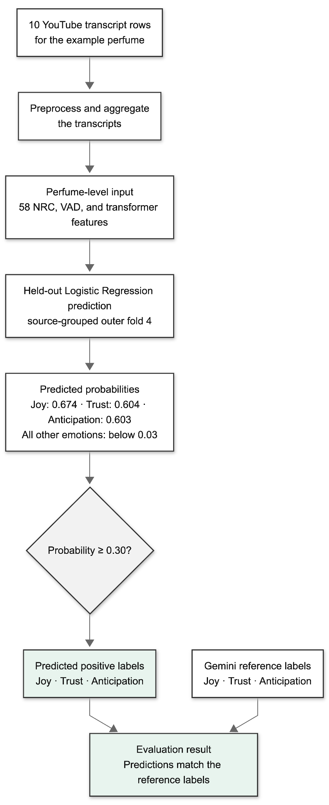
Figure 9: Perfume-level source-to-prediction trace.

1.3 BERT Checkpoint Cache and Revision Record
The accepted BERT run, bert_seed42_source_grouped5, loaded monologg/bert-base-cased-goemotions-original from local model files. The project repository documents this identifier as the Original GoEmotions Taxonomy checkpoint [13]. The saved run configuration records local_files_only=true. The runner recorded the checkpoint repository but did not prospectively pass or persist an immutable Hugging Face revision.
A post-run cache inspection identified the exact BERT checkpoint revision used in the experiment. The checkpoint configuration, tokenizer, vocabulary, and model weights were recorded with SHA-256 checksums to support reproducibility. The complete verification record is stored in the model-benchmark logs directory.
This evidence identifies the cached revision and bytes observed immediately after the accepted run. It is a supporting post-run record, not evidence that the revision was prospectively pinned. A future exact rerun should pass the recorded immutable revision explicitly.

APPENDIX 2: SUPPLEMENTAL DIAGNOSTIC TABLES

2.1 Exploratory XGBoost Synthetic Sensitivities
The following legacy XGBoost review-count and balancing sweeps are retained as exploratory diagnostics. They are distinct from the formal fixed weighted 784×3 XGBoost comparison reported with the five-model analysis in Chapter IV. Table 17 varies how many synthetic reviews enter source-isolated training folds; all scores use held-out YouTube perfumes, and rows linked to held-out identities are excluded.

Table 17: Exploratory XGBoost synthetic review-count sweep evaluated on held-out YouTube perfumes
Added synthetic reviews | Synthetic perfumes | Macro-F1 | Change vs YouTube-only | Macro ROC-AUC | Macro average precision
0 | 0 | 0.3260 | 0.0000 | 0.5683 | 0.3094
99 | 33 | 0.3251 | -0.0009 | 0.5945 | 0.3061
201 | 67 | 0.3241 | -0.0018 | 0.5991 | 0.3084
300 | 100 | 0.3217 | -0.0042 | 0.5780 | 0.3058
501 | 167 | 0.3277 | +0.0018 | 0.5941 | 0.3028
1,002 | 334 | 0.3226 | -0.0033 | 0.5617 | 0.3015
2,001 | 667 | 0.3235 | -0.0025 | 0.5838 | 0.3020
2,352 | 784 | 0.3269 | +0.0009 | 0.5890 | 0.3066

The review-count sweep is non-monotonic. Its largest macro-F1 point estimate is 0.3277 with 501 added reviews, only 0.0018 above the YouTube-only row, while macro AP is lower. It therefore does not show that adding more synthetic reviews consistently improves held-out YouTube classification.
Table 18 reports a separate post hoc balancing grid. In this table, “No balancing” means scale_pos_weight=1.0 with no resampling. Its YouTube-only row is therefore a different XGBoost configuration from the label-weighted XGBoost result reported in Chapter IV.

Table 18: Exploratory XGBoost balancing sensitivity across YouTube-only, 784×3, and 784×6 training conditions, evaluated on held-out YouTube perfumes
Training data | Method | Macro-F1 | Macro ROC-AUC | Macro average precision
YouTube only | No balancing | 0.3242 | 0.5351 | 0.2979
YouTube only | Hybrid | 0.2230 | 0.5328 | 0.3049
YouTube only | SMOTE | 0.3404 | 0.5668 | 0.3150
YouTube + 784×3 | No balancing | 0.3303 | 0.5770 | 0.3086
YouTube + 784×3 | Hybrid | 0.3140 | 0.5669 | 0.3131
YouTube + 784×3 | SMOTE | 0.3258 | 0.6013 | 0.3059
YouTube + 784×6 | No balancing | 0.3297 | 0.6051 | 0.3651
YouTube + 784×6 | Hybrid | 0.3794 | 0.5900 | 0.3531
YouTube + 784×6 | SMOTE | 0.3517 | 0.5819 | 0.3074

Different metrics favor different rows, and the apparent leaders were selected from several data-size and balancing combinations. The experiment also mixes perfume-level YouTube aggregates with three or six synthetic review rows per perfume. These results are therefore setup-dependent exploratory sensitivities, not evidence that one balancing or augmentation policy is generally superior.

2.2 Aggregate Confusion Totals
Table 19 reports aggregate confusion totals for the supplementary seed-42 analysis. Each row sums the seven label decisions across 784 perfumes. Chapter IV discusses the prediction patterns needed to interpret the main results. The experiment files retain the complete label-level counts.

Table 19: Seed-42 Aggregate seven-label confusion totals for the five YouTube-only supervised models at threshold 0.3 across 784 perfumes
Model | TP | FP | TN | FN
Logistic Regression, class-weighted | 1,369 | 1,296 | 2,651 | 172
XGBoost | 1,296 | 732 | 3,215 | 245
Random Forest | 1,448 | 865 | 3,082 | 93
BERT | 1,466 | 891 | 3,056 | 75
BiLSTM with Attention | 1,521 | 2,808 | 1,139 | 20

2.3 Annotation-Packet Source Verification
An automated source audit found that, for 174 of the 784 YouTube items (22.2%), neither selected source excerpt contained a detected perfume-name alias or anchor-token match. This detector result does not establish that the excerpts were irrelevant or that their labels were incorrect, because perfumes may be discussed indirectly and transcription variation can prevent automatic matching.
A deterministic spot check sampled 20 of the 174 flagged items using seed 42. In all 20 cases, the packet excerpt exactly matched the bounded text preserved from its selected source chunk, and the associated source video identifiers and URLs remained recoverable. This check verified packet-to-source traceability; it did not evaluate topical relevance or label correctness.

APPENDIX 3: ANNOTATION PROMPTS AND OPERATIONAL LABEL DEFINITIONS
This appendix reproduces the fixed instruction blocks used to prepare the browser-based model-assisted annotation packets. Batch-specific identifiers and review evidence were appended programmatically after each instruction block. The YouTube packets used perfume-level items with one or two bounded excerpts; the synthetic packets used one generated review per item. The eight emotion names follow the NRC Emotion Lexicon inventory [5], [6], while the descriptions in Section 3.3 of this appendix are project-specific operational definitions rather than quoted dictionary definitions.

3.1 YouTube perfume-level prompt
You are labeling perfume review text for an academic thesis.
Task: For each perfume item in the batch, assign emotion-tone labels using ONLY the review excerpts provided.
Rules:
- Label each perfume item independently.
- Do NOT infer from brand, perfume name, reputation, note list, marketing concept, or niche status.
- Labels reflect the reviewers' emotional tone expressed in the provided excerpts.
- Set an emotion to 1 only when there is clear linguistic evidence. Otherwise set it to 0.
- Multiple emotions can be 1.
- Surprise=1 only when the text explicitly expresses unexpectedness, such as "surprised", "did not expect", "caught me off guard", or similar language.
- Anticipation=1 when the text clearly expresses expectation, looking forward, curiosity, desire to keep testing, hype, or waiting for something to unfold.
- Trust=1 when the text clearly expresses comfort, safety, reliability, attachment, reassurance, confidence, or recommendation.
- Arousal means emotional activation or calmness, not perfume strength or projection.
- Dominance means confidence/control/assertiveness, not perfume loudness unless framed as personal power/control.
- If emotional evidence is weak or neutral, use all emotions=0 and valence=5, arousal=5, dominance=5.
- For VAD, judge the overall emotional tone across the excerpts.
Emotion columns, binary 0/1:
joy,sadness,anger,fear,trust,surprise,anticipation,disgust
VAD columns, integer 1-9:
valence: 1 very negative, 5 neutral, 9 very positive
arousal: 1 very calm, 5 neutral, 9 highly activated
dominance: 1 passive/gentle, 5 neutral, 9 commanding/confident
Return no markdown, no explanation, and no code fences.
CSV validity is mandatory: if any field contains a comma, wrap that field in double quotes.
Do not shorten, paraphrase, or add ellipses to item_id, source_type, perfume_id, or perfume_name.
Copy those identifier fields exactly from each input item.
Apart from the batch tracking line requested below, return only the CSV header and rows.
Use exactly this CSV header:
item_id,source_type,perfume_id,perfume_name,joy,sadness,anger,fear,trust,surprise,anticipation,disgust,valence,arousal,dominance
Return exactly one output row per input perfume item.
Each batch then specified the required tracking line and supplied records in the following template:
RESPONSE FORMAT
Start your response with exactly this tracking line: OG Batch {batch_number} output:
Then immediately output the CSV header and one CSV row per input perfume item.
INPUT BATCH
BEGIN_ITEM
item_id: {item_id}
source_type: {source_type}
perfume_id: {perfume_id}
perfume_name: {perfume_name}
source_review_count: {source_review_count}
review_excerpt_1: {bounded excerpt}
review_excerpt_2: {bounded excerpt, when available}
END_ITEM

3.2 Synthetic review-level prompt
You are labeling perfume review text for an academic thesis.
Task: For each review in the batch, assign emotion-tone labels using ONLY the review text provided.
Rules:
- Label each review independently.
- Do NOT infer from brand, perfume name, reputation, note list, marketing concept, or niche status.
- Labels reflect the reviewer's emotional tone expressed in the text.
- Set an emotion to 1 only when there is clear linguistic evidence. Otherwise set it to 0.
- Multiple emotions can be 1.
- Surprise=1 only when the text explicitly expresses unexpectedness, such as "surprised", "did not expect", "caught me off guard", or similar language.
- Anticipation=1 when the text clearly expresses expectation, looking forward, curiosity, desire to keep testing, or waiting for something to unfold.
- Trust=1 when the text clearly expresses comfort, safety, reliability, attachment, reassurance, or confidence in wearing the perfume.
- Arousal means emotional activation or calmness, not perfume strength or projection.
- Dominance means confidence/control/assertiveness, not perfume loudness unless framed as personal power/control.
- If emotional evidence is weak or neutral, use all emotions=0 and valence=5, arousal=5, dominance=5.
Emotion columns, binary 0/1:
joy,sadness,anger,fear,trust,surprise,anticipation,disgust
VAD columns, integer 1-9:
valence: 1 very negative, 5 neutral, 9 very positive
arousal: 1 very calm, 5 neutral, 9 highly activated
dominance: 1 passive/gentle, 5 neutral, 9 commanding/confident
Return no markdown, no explanation, and no code fences.
Apart from the batch tracking line requested below, return only the CSV header and rows.
Use exactly this CSV header:
synthetic_review_id,source_type,perfume_id,perfume_name,review_index,joy,sadness,anger,fear,trust,surprise,anticipation,disgust,valence,arousal,dominance
Return exactly one output row per input review.
Each batch then specified the required tracking line and supplied records in the following template:
RESPONSE FORMAT
Start your response with exactly this tracking line: {batch_label} output:
Then immediately output the CSV header and one CSV row per input review.
INPUT BATCH
BEGIN_REVIEW
synthetic_review_id: {synthetic_review_id}
source_type: synthetic
perfume_id: {perfume_id}
perfume_name: {perfume_name}
review_index: {review_index}
review_text: {review_text}
END_REVIEW

3.3 Operational interpretation of emotion labels
• Joy: positive enjoyment, delight, pleasure, or affection.
• Sadness: melancholy, loss, disappointment, or an emotionally downbeat tone.
• Anger: irritation, annoyance, frustration, resentment, or explicitly angry rejection.
• Fear: anxiety, unease, intimidation, or threatening emotional tone.
• Trust: comfort, reliability, reassurance, attachment, confidence, or recommendation.
• Surprise: explicit unexpectedness, being caught off guard, or not expecting an effect.
• Anticipation: expectation, curiosity, desire to keep testing, hype, or waiting for a scent to unfold.
• Disgust: aversion, repulsion, revulsion, or strongly negative sensory rejection.
As described in Section 4.1.2, anger is retained in the annotation schema for completeness but excluded from the official seven-label benchmark because its positive support is too limited for stable evaluation across the 784-perfume comparison.

CURRICULUM VITAE

Ece ÇANGA
Place and Date of Birth: Ankara, 28 May 1998
Education
2023–2026 M.Sc. in Computer Engineering, Çankaya University
2016–2022 B.Sc. in Computer Science, Bilkent University
Professional Experience
2022–2026 Software Engineer, ASELSAN / BITES – Defense & Aerospace Systems
2022 Software Engineer Intern, LiftOS (formerly 10Lift)
2020 Software Engineer Intern, ASELSAN
2019 Software Engineer Intern, BITES – Defense & Aerospace Technologies
2019 Digital Design Laboratory Tutor, Bilkent University
Honors and Certificates
Certificate of Honor, Bilkent University; Java Certification, HackerRank; React Native & GraphQL Certificate, BrightTalk; CSFair Traveler Award, Bilkent University; and Certificate of Honor, Ministry of Education.
Research Interests
Natural Language Processing, Sentiment and Emotion Analysis, Machine Learning, Deep Learning, and Software Engineering.

